SPIMS+ SMART PLACEMENT AND INTERNSHIP MANAGEMENT SYSTEM

A PROJECT REPORT

Submitted by
AADHARSH R(727723EUCS001)
BARATH HARIHARAN K(727723EUCS031)
DHARANEESH D(727723EUCS043)

In partial fulfilment for the award of the degree
of

BACHELOR OF ENGINEERING
IN
COMPUTER SCIENCE AND ENGINEERING

SRI KRISHNA COLLEGE OF ENGINEERING AND TECHNOLOGY
An Autonomous Institution |Approved by AICTE | Affiliated to Anna University |
Accredited by NAAC with A++ Grade
Kuniamuthur, Coimbatore – 641008.

MARCH 2026


SRI KRISHNA COLLEGE OF ENGINEERING AND TECHNOLOGY
An Autonomous Institution |Approved by AICTE | Affiliated to Anna University |
Accredited by NAAC with A++ Grade
Kuniamuthur, Coimbatore – 641008.

BONAFIDE CERTIFICATE

Certified that this project report titled “SPIMS+ SMART PLACEMENT AND INTERNSHIP MANAGEMENT SYSTEM” is the bonafide work of “AADHARSH R (727723EUCS001) , BARATH HARIHARAN K (727723EUCS031), DHARANEESH D(727723EUCS043)”who carried out the project work under my supervision.

SIGNATURE SIGNATURE
Dr. Senthilnathan Ms.Anitha.P
HEAD OF THE DEPARTMENT SUPERVISOR
PROFESSOR ASSISTANT PROFESSOR

Submitted for the Project viva-voce examination held on

INTERNAL EXTERNAL

ABSTRACT
SPIMS (Smart Placement and Internship Management System) is a modern web-based application designed to streamline and digitize the management of campus recruitment and internship drives in educational institutions. It focuses on intelligently handling student profiles, eligibility, and placement workflows to ensure effective outcomes for both students and recruiters.
The proposed system addresses these challenges by providing an integrated digital platform that enables efficient management of student data, company requirements, and drive schedules. The application allows placement officers to create and manage placement drives, automatically filter eligible students based on predefined criteria, and track selection status across multiple rounds. Students can view upcoming opportunities, receive personalized notifications, and monitor their application status and offers through an intuitive dashboard.
The system is developed using modern web technologies, including React for the frontend, Tailwind CSS for responsive user interface design, and Express Js for backend services. MongoDB is used as the database for reliable and structured data storage. The application also integrates notification services, including in-app alerts and email messaging, to provide timely updates and improve engagement between students, placement officers, and recruiters.
Overall, SPIMS improves the efficiency, transparency, and accuracy of campus placement management. It demonstrates how digital transformation can support educational institutions by providing a scalable, user-friendly, and data-driven solution. The system can be further extended with features such as mobile applications, AI-based candidate–job matching, and integration with external job portals, making it a future-ready platform for modern campus recruitment management.

TABLE OF CONTENTS
CHAPTER NO | TITLE | PAGE NO
 | ACKNOWLEDGEMENT | iii
 | ABSTRACT | iv
 | TABLE OF CONTENTS | v
 | LIST OF FIGURES | vii
 | LIST OF ABBREVIATIONS | viii
1 | INTRODUCTION | 1
 | 1.1 GENERAL / OVERVIEW | 1
 | 1.2 PROBLEM STATEMENT | 2
 | 1.3 OBJECTIVES | 3
 | 1.4 SCOPE OF THE PROJECT | 4
2 | LITERATURE REVIEW | 5
 | 2.1 GENERAL | 5
 | 2.2 EXISTING SYSTEMS | 6
 | 2.3 COMPARATIVE ANALYSIS | 7
 | 2.4 LIMITATIONS OF EXISTING SYSTEMS | 8
 | 2.5 NEED FOR THE PROPOSED SYSTEM | 9
 | 2.6 SUMMARY | 10
3 | SYSTEM ANALYSIS | 11
 | 3.1 GENERAL | 11
 | 3.2 EXISTING SYSTEM | 12
 | 3.3 PROPOSED SYSTEM | 13
 | 3.4 FEASIBILITY STUDY | 14
 | 3.5 REQUIREMENTS ANALYSIS | 15
 | 3.6 SYSTEM REQUIREMENTS | 16
 | 3.7 DATA FLOW OVERVIEW | 17
 | 3.8 SUMMARY | 18
4 | SYSTEM DESIGN | 19
 | 4.1 GENERAL | 19
 | 4.2 SYSTEM ARCHITECTURE OVERVIEW | 20
 | 4.3 USER AUTHENTICATION FLOW | 21
 | 4.4 TPO–STUDENT–RECRUITER PLACEMENT MANAGEMENT FLOW | 22
 | 4.5 AI MATCHING ENGINE DESIGN | 23
 | 4.6 PLACEMENT ANALYTICS SYSTEM | 24
 | 4.7 API ROUTES STRUCTURE | 25
 | 4.8 DATABASE DESIGN (MONGODB) | 26
 | 4.9 CORE COMPONENTS | 27
 | 4.10 SECURITY FEATURES | 28
 | 4.11 DEVELOPMENT STACK | 29
 | 4.12 UML DIAGRAMS | 30
 | 4.13 SUMMARY | 31
5 | IMPLEMENTATION | 32
6 | TESTING | 36
7 | RESULTS AND DISCUSSION | 42
8 | CONCLUSION AND FUTURE ENHANCEMENTS | 47
9 | SCREENSHOTS | 50
 | REFERENCES | 55
 | APPENDICES | 57

LIST OF FIGURES
FIGURE NO | TITLE | PAGE NO
4.1 | System Architecture Diagram | 20
4.2 | User Authentication Flow | 21
4.3 | TPO–Student–Recruiter Placement Management Flow | 22
4.4 | AI Matching Engine Design | 23
4.5 | Placement Analytics System | 24
4.6 | API Routes Structure | 25
4.7 | Database Schema Diagram | 26
4.8 | Use Case Diagram | 30
4.9 | Sequence Diagram | 30

LIST OF ABREVIATIONS
ABBREVIATION | FULL FORM
API | Application Programming Interface
JWT | JSON Web Token
UI | User Interface
UX | User Experience
DB | Database
REST | Representational State Transfer
NPM | Node Package Manager
JSX | JavaScript XML
SMS | Short Message Service
AI | Artificial Intelligence
IoT | Internet of Things
UAT | User Acceptance Testing

CHAPTER 1
INRODUCTION
1.1 GENERAL / OVERVIEW
SPIMS (Smart Placement and Internship Management System) is a centralized web-based platform for managing campus recruitment and internship activities in educational institutions. It focuses on organizing student information, placement workflows, and recruiter engagement in a structured and efficient manner. These activities require proper coordination, planning, and ongoing tracking to achieve successful placement outcomes.
In many institutions, placement processes are still handled manually using spreadsheets or simple standalone tools. This causes inefficiencies, data inconsistency, and difficulty in maintaining accurate records of student eligibility, applications, and offers across multiple recruitment drives.
SPIMS is developed to overcome these limitations by providing an integrated platform for managing student profiles, company requirements, placement drives, and selection status.
The system uses technologies such as React and Tailwind CSS for a responsive interface, with Express Js and MongoDB on the backend for secure and reliable data handling. It also supports timely updates and basic analytics, helping placement officers and recruiters make better decisions.

1.2 PROBLEM STATEMENT
The current system used in most educational institutions for campus placements has several limitations:
- Difficulty in tracking each student’s eligibility, registrations, and selection status across multiple drives
- Inefficient planning and scheduling of recruitment activities, which can cause clashes, missed deadlines, or confusion
- No automated, centralized notification system to keep students updated about drives, tests, results, and changes
Due to these issues, both placement officers and students struggle to maintain a smooth, transparent, and well-organized placement process.
1.3 OBJECTIVES
The main objectives of the proposed system are:
- To develop a web-based platform for managing campus placements and internships
- To automate eligibility checking, drive creation, and application tracking
- To deliver a responsive and user-friendly interface for students, placement officers, and recruiters
1.4 SCOPE OF THE PROJECT
The scope of SPIMS includes:
- Management of campus placement drives and internship opportunities
- Tracking student profiles, eligibility, applications, and selection status
- Providing dashboards for students, placement officers, and company recruiters

CHAPTER 2
LITERATURE REVIEW
2.1 GENERAL
The literature review provides an understanding of existing systems and technologies related to campus placement management, student recruitment platforms, and eligibility tracking. It helps in identifying the limitations of current solutions and justifies the need for the proposed system.
In the educational domain, various digital systems have been developed to manage student records, job postings, and recruitment processes. However, most of these systems are generic and not specifically designed for campus placement workflows such as intelligent eligibility matching and drive coordination.
This chapter analyzes existing solutions and highlights their strengths and weaknesses, forming the foundation for the proposed SPIMS platform.
2.2 EXISTING SYSTEMS
2.2.1 Creatrix Campus Placement Management System
Creatrix is a SaaS platform for higher education that automates student profiling, company management, and placement analytics through integrated TPO dashboards
Features:
- Student profiling with academic and skill data
- Employer management and job posting
- Automated eligibility filtering and job fitment
- Omni-channel notifications (email, SMS)
- Integration with college ERP/SIS systems
Limitations:
- Primarily focused on large institutions (expensive licensing)
- Limited customization for specific eligibility criteria
- Analytics not advanced enough for predictive placement trends
2.2.2 Camu Placement Management Software
Camu provides end-to-end placement automation within its digital campus ERP for student registration and recruiter coordination.
Features:
- Student registration, recruiter management, and scheduling
- Eligibility tracking and document management
- Mobile-accessible dashboards for students/recruiters
- Advanced analytics integrated with digital campus platform
Limitations:
- Part of a larger ERP suite (not standalone)
- Limited AI-based matching or recommendation features
- Dependency on Camu's ecosystem for full functionality
2.2.3 Edumarshal Training & Placement Management System
Edumarshal offers complete placement lifecycle management with student profiles, company coordination, and mobile app notifications.
Features:
- Complete placement lifecycle management
- Student profile management and skill assessment
- Company coordination, drive scheduling, and interviews
- Placement analytics and MIS reports
Limitations:
- Subscription-based (high recurring costs)
- Limited flexibility for custom eligibility rules
- Integration limited to their ERP ecosystem
2.3 COMPARATIVE ANALYSIS
Feature | Creatrix | Camu | Edumarshal | Spims+
Student Profile | ✔ | ✔ | ✔ | ✔
Eligibility Filtering | ✔ | Limited | Limited | ✔
Drive Management | ✔ | ✔ | ✔ | ✔
Centralised Notifications | ✔ | ✔ | ✔ | ✔
AI Matching | Limited | ✖ | Limited | ✔
Custom Eligibility Rules | Limited | ✖ | Limited | ✔
Cost-Effective | ✖ | ✖ | ✖ | ✔

2.4 LIMITATIONS OF EXISTING SYSTEMS
From the above analysis, the major limitations are:
- Lack of domain-specific features for intelligent campus placement workflows
- No integration of eligibility checking with AI-driven student-job matching
- Absence of real-time placement analytics and performance monitoring
- Limited user interaction and poor interface design for multiple stakeholders
- No automated centralized communication replacing scattered notifications
These limitations reduce the efficiency of campus recruitment management and affect placement success rates.
2.5 NEED FOR THE PROPOSED SYSTEM
The proposed SPIMS system is designed to overcome the limitations of existing systems by:
- Providing a unified platform for campus placement management
- Integrating eligibility checking, AI matching, and drive coordination
- Offering real-time dashboards and placement analytics
- Enabling centralized role-based communication for all stakeholders
- Delivering a modern, responsive user experience
The system aims to enhance both placement officer efficiency and student placement success.
2.6 SUMMARY
This chapter reviewed various existing systems related to campus placement and recruitment management. It identified key gaps such as lack of intelligent matching functionality, absence of customizable analytics, and poor integration of features.
The proposed SPIMS system addresses these gaps by offering a comprehensive solution tailored for campus placement management.

CHAPTER 3
SYSTEM ANALYSIS
3.1 GENERAL
System analysis is the process of studying the current system, identifying its limitations, and proposing a new system that improves efficiency and performance. It plays a crucial role in understanding user requirements and defining system functionalities.
In this project, the analysis focuses on evaluating the campus placement management system and designing a modern web-based solution to overcome its limitations.
3.2 EXISTING SYSTEM
The existing system used in many colleges for campus placements is primarily manual or semi-digital.
3.2.1 Description of Existing System
- Student details are recorded manually in Excel sheets or forms
- Placement drives are scheduled using WhatsApp groups or notice boards
- Application tracking is inconsistent across multiple companies
- Communication with students is mostly through scattered channels
3.2.2 Disadvantages of Existing System
- High chances of human error in eligibility verification
- Data loss due to scattered spreadsheets and documents
- Time-consuming manual coordination processes
- No centralized data management for placement history
- Lack of real-time updates on drive status
- Poor student engagement due to fragmented communication
These drawbacks reduce the overall efficiency and effectiveness of campus placement management.
3.3 PROPOSED SYSTEM
The proposed system, SPIMS, is a web-based application that automates and digitizes campus placement management.
3.3.1 Description of Proposed System
- Centralized database for student profiles and company requirements
- Automated eligibility checking using policy-based filtering
- Real-time tracking of applications and selection status
- Role-based communication system for all stakeholders
- Analytics dashboard for placement performance visualization
3.3.2 Advantages of Proposed System
- Improved accuracy and reduced manual verification errors
- Efficient drive coordination and scheduling
- Real-time monitoring and status updates
- Data-driven decision making with placement analytics
3.4 FEASIBILITY STUDY
Feasibility study determines whether the proposed system is practical and implementable.

3.4.1 Technical Feasibility
The system uses modern technologies such as:
- React (Frontend)
- Tailwind CSS (Styling)
- Node Js (Backend services)
- MongoDb (Database)
These technologies are widely available, easy to use, and suitable for building scalable applications.
Conclusion: Technically feasible.
3.4.2 Economic Feasibility
- Uses open-source tools → No licensing cost
- Low development cost
- Reduces operational expenses
Conclusion: Economically feasible.
3.4.3 Operational Feasibility
- User-friendly interface
- Easy to learn and use
- Requires minimal training
Conclusion: Operationally feasible.
3.5 REQUIREMENTS ANALYSIS
3.5.1 Functional Requirements
The system must perform the following functions:
- User login and role-based authentication (students, faculty, TPOs, recruiters,Alumni)
- Automated eligibility checking and policy enforcement
- AI-driven student-job matching and candidate ranking
- Centralized notifications and role-based communication
- Real-time analytics dashboards for placement progress and metrics
3.5.2 Non-Functional Requirements
- Performance: Fast response time
- Security: Secure user authentication and data protection
- Usability: Simple and intuitive interface
- Scalability: Ability to handle more users in future
- Reliability: System should be stable and error-free
3.6 SYSTEM REQUIREMENTS
3.6.1 Hardware Requirements
- Processor: Intel i3 or above
- RAM: 4 GB minimum
- Storage: 500 GB
3.6.2 Software Requirements
- Operating System: Windows/Linux
- Frontend: React.js
- Styling: Tailwind CSS
- Browser: Chrome/Edge

3.7 DATA FLOW OVERVIEW
The system follows a simple data flow:
- User inputs data through UI
- Data is sent to backend via API
- Data is processed and stored in database
- Results are returned and displayed
3.8 SUMMARY
This chapter analyzed the existing campus placement system and identified its limitations. It introduced the proposed SPIMS system and demonstrated its advantages. The feasibility study confirmed that the system is practical, cost-effective, and easy to implement.
The requirements analysis clearly defined the functionalities and constraints of the system, forming the foundation for system design.

CHAPTER 4
SYSTEM DESIGN
4.1 GENERAL
System design is the process of defining the architecture, components, modules, interfaces, and data of a system. It acts as a blueprint for the implementation of the proposed system.
SPIMS is designed as a scalable web platform with modular AI services. It integrates profile management, eligibility automation, AI matching, role-based communication, and analytics into a unified system.
4.2 SYSTEM ARCHITECTURE OVERVIEW
The system follows a client-server architecture with multiple layers:
- Frontend Layer: Built using React + Vite and Tailwind CSS
- Backend Layer: Node.js + Express handling business logic
- Database Layer: MongoDB for data storage
- External Services:Gen AI Tools like Gemni,Ollama,Groq and FireBase for Push notifications.
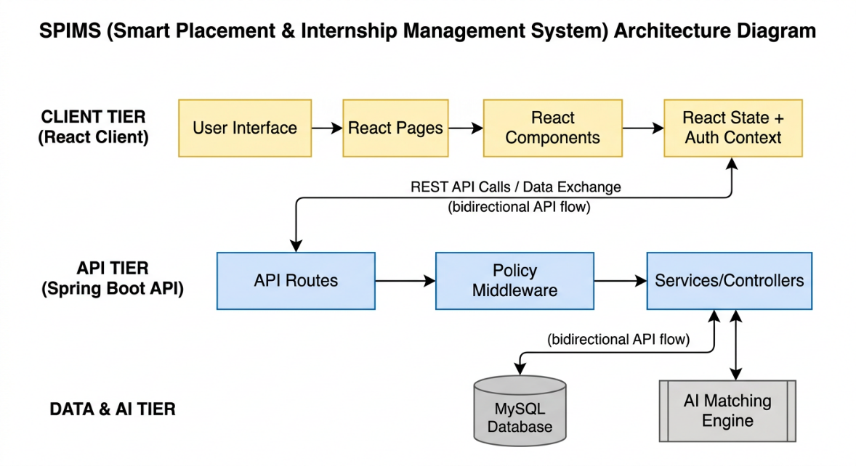
Figure 4.1: System Architecture Diagram
Description:
The system architecture diagram shows the interaction between the frontend, backend, database, and external services. The user interacts with the frontend, which communicates with the backend APIs. The backend processes requests and interacts with the MongoDB database and Twilio service for notifications.

4.3 USER AUTHENTICATION FLOW
The system uses JWT-based authentication for secure access.
Process:
- User (Student/TPO/Recruiter) logs in/registers via React UI
- Credentials sent to Express Js API endpoints
- Backend validates against MongoDB user data
- JWT token generated with role-based claims
- Token returned to frontend for secure storage
- Token used in Authorization header for protected API routes

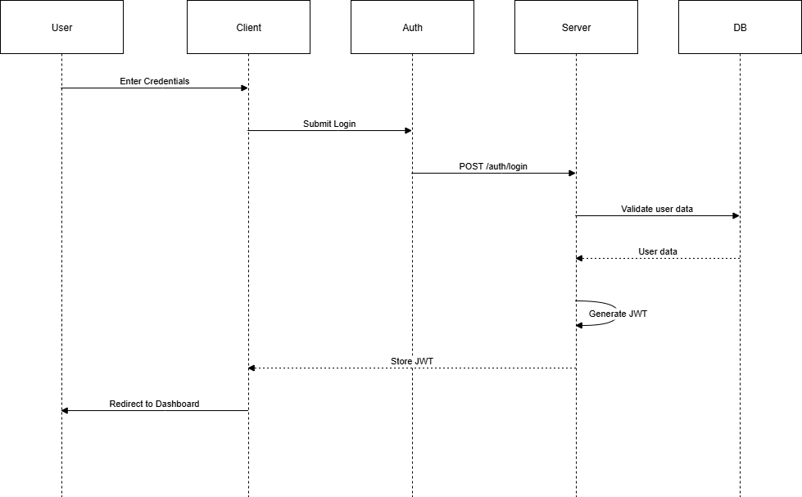Figure 4.2: User Authentication Flow
Description:
This diagram illustrates the authentication process where user credentials are validated and a JWT token is issued for secure communication and access to protected resources.
4.4 TPO–Student–Recruiter Placement Management Flow
This module manages interaction between TPO, students, and recruiters throughout the placement cycle.
Process:
- Recruiter creates placement drive and posts company opportunity
- Eligible students automatically filtered by policy engine
- Students view opportunities and submit applications
- AI matching ranks candidates for recruiter review
- TPO tracks application status and approval workflow
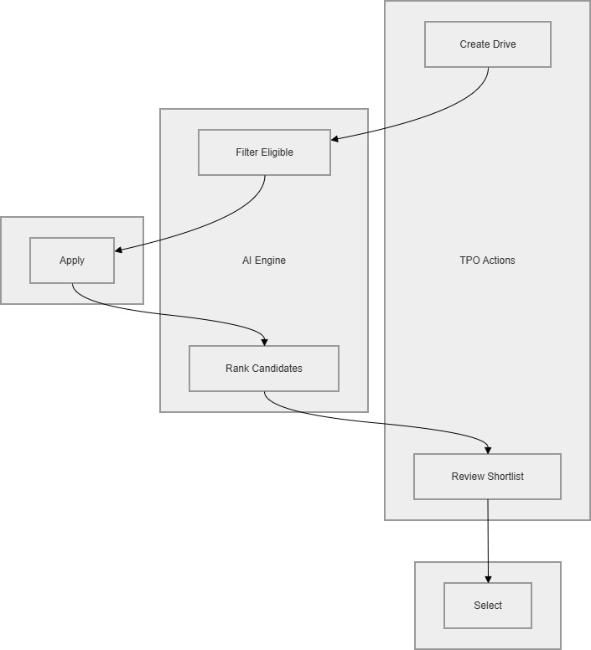Figure 4.3: TPO–Student–Recruiter Placement Management Flow
Description:
This diagram represents the lifecycle of campus placement management, including student profile creation, eligibility assignment, drive scheduling, AI matching, and placement tracking.
4.5 AI MATCHING ENGINE DESIGN
The notification system ensures timely communication with users.
Matching Criteria:
- Academic performance and CGPA thresholds
- Skill-based profile analysis
- Company-specific eligibility policies
- Placement drive preferences
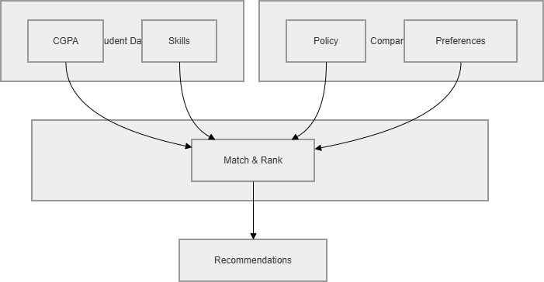
Figure 4.4: AI Matching Engine Design
Description:
This diagram shows how eligibility events trigger AI matching, which is processed by the backend engine and delivered through real-time rankings and student recommendations to TPOs.
4.6 PLACEMENT ANALYTICS SYSTEM
This module tracks placement performance and recruitment effectiveness.
Features:
- Drive-wise application tracking
- Conversion metrics monitoring
- Student selection status updates
- Visual analytics dashboard
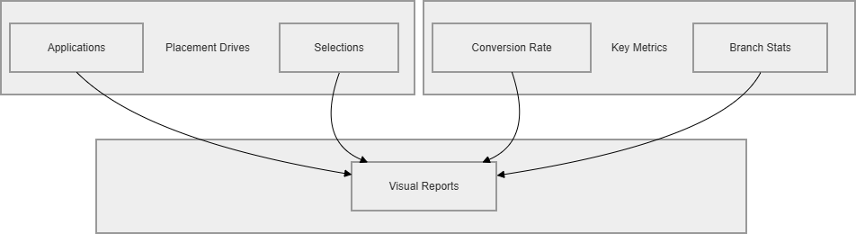Figure 4.5: Placement Analytics System Flow
Description:
This diagram illustrates how data from placement drives is collected, stored, processed through AI algorithms, and displayed as interactive analytics in the TPO dashboard.
4.7 API ROUTES STRUCTURE
The backend is organized into structured API routes:
4.7.1 Public Routes
- /auth/login
- /auth/signup
- /auth/students

4.7.2 Protected Routes
- /api/placements
- /api/eligibility
- /api/matching
- /api/analytics
4.7.3 Admin Routes
- /admin/placements
- /admin/analytics
- /admin/eligibility-policies
- /admin/test-matching
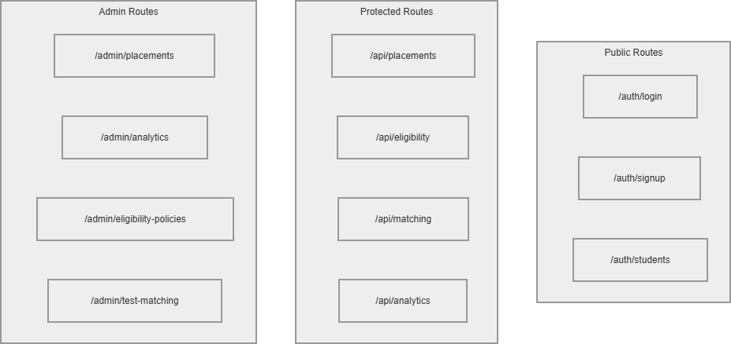Figure 4.6: API Routes Structure
Description:
This diagram represents the hierarchical structure of API routes categorized into public, protected, and admin routes for the SPIMS platform.
4.8 DATABASE DESIGN (MONGODB)
The system uses MongoDB for flexible and scalable data storage.
Collections:
Student Collection
- student_id (PK)
- name
- email
- cgpa
- skills
- branch
PlacementDriveCollection
- drive_id (PK)
- company_name
- start_date
Eligibility Collection
- eligibility_id (PK)
- student_id (FK)
- drive_id (FK)
- status
- match_score
Application Collection
- application_id (PK)
- student_id (FK)
- drive_id (FK)
- status
- applied_date
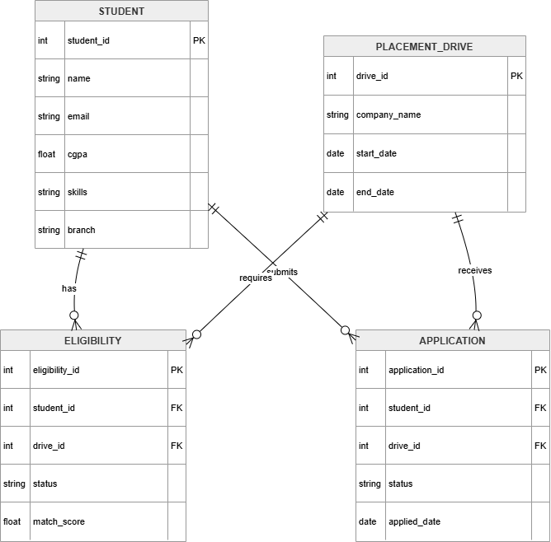Figure 4.7: Database Schema Diagram
Description:
This diagram shows the relationships between students, placement drives, eligibility records, applications, and analytics tables in the MongoDB database.
4.9 CORE COMPONENTS
4.9.1 Authentication System
- JWT-based authentication
- Role-based access control

4.9.2 Student Management
- Student profile management
- Academic record verification
- Eligibility policy assignment
4.9.3 AI Matching Engine
- Skill-based profile analysis
- Company requirement matching
- Real-time ranking generation
4.9.4 Placement Analytics
- Drive performance metrics
- Conversion rate tracking
- Branch-wise placement reports
4.9.5 UI Componeents
- TPO Dashboard
- Student Portal
- Drive Management Panel
- Analytics Dashboard
4.10 SECURITY FEATURES
- Secure authentication using JWT
- Protected API routes
- Role-based authorization
- Safe data storage
4.11 DEVELOPMENT STACK
Component | Technology
Frontend | React + Vite
Backend | Node.js + Express
Database | MongoDB
UI | Tailwind CSS
State Management | React Context
Authentication | JWT
External Service | Gen AI Tools
4.12 UML DIAGRAMS
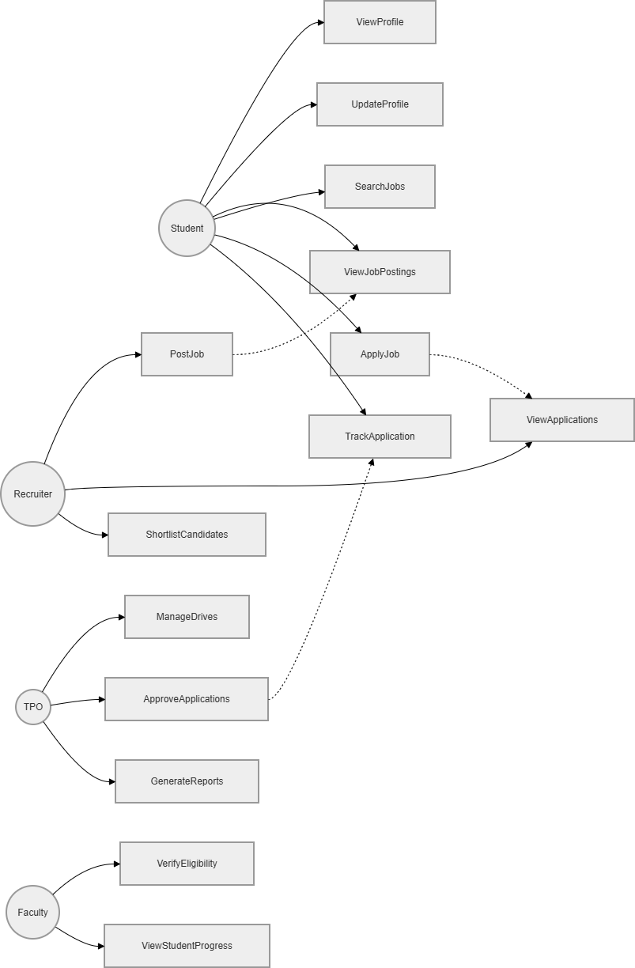
Figure 4.8: Use Case Diagram

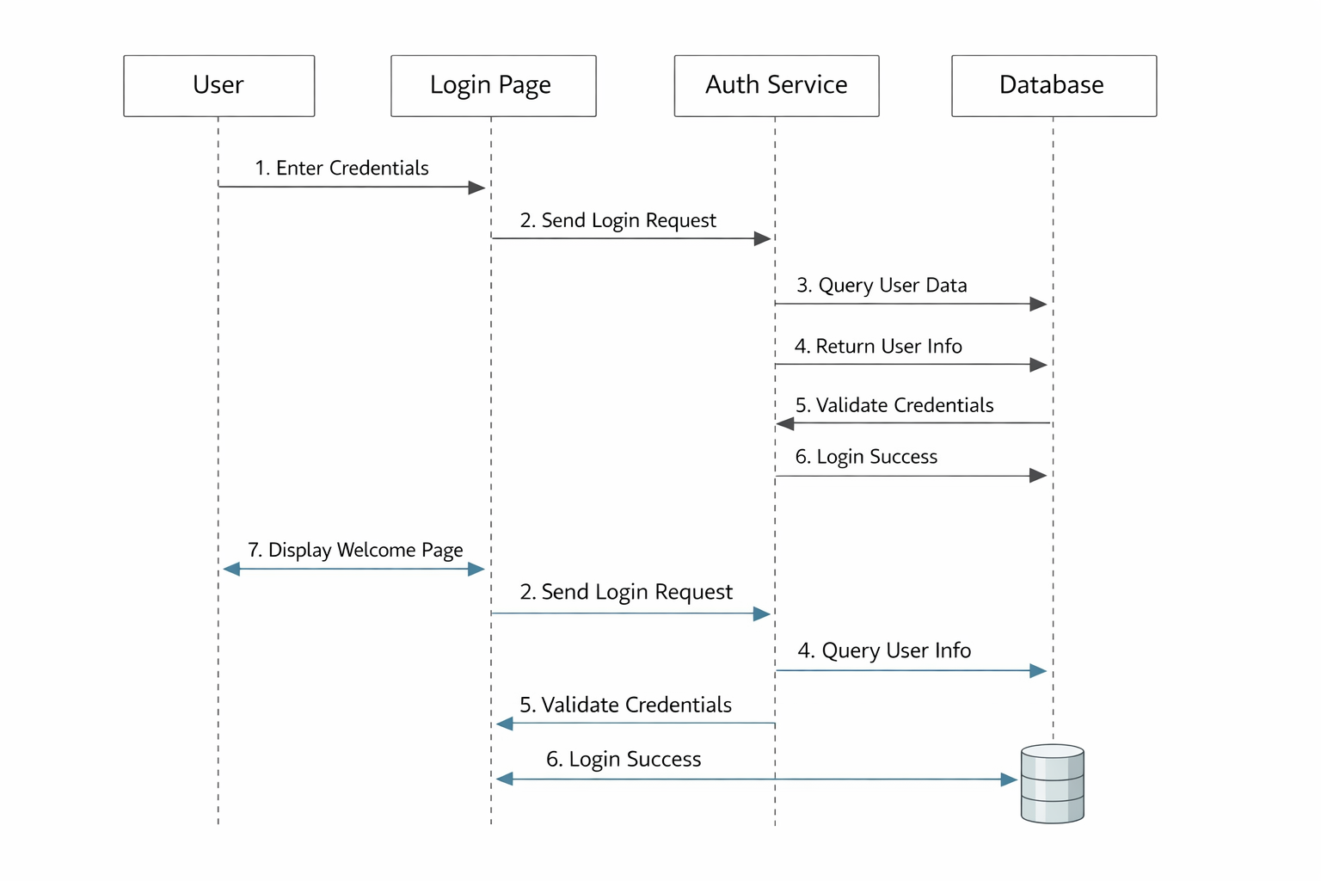Figure 4.9: Sequence Diagram
4.13 SUMMARY
This chapter presented the complete system design of the SPIMS Intelligent Campus Placement Platform. It covered architecture, authentication flow, API structure, database schema, and core components.
The design ensures scalability, security, and efficient placement processing performance, forming the foundation for successful implementation.

CHAPTER 5
IMPLEMENTATION
5.1 GENERAL
Implementation is the phase where the system design is converted into a working application. SPIMS is implemented using modern web technologies to ensure scalability, responsiveness, and performance.​
The system follows a modular approach with separate components for profile management, eligibility automation, AI matching, and analytics, later integrated into a complete platform.
5.2 DEVELOPMENT ENVIRONMENT
The development environment includes tools and technologies used to build the system.
5.2.1 Frontend
- React.js (with Vite)
- Tailwind CSS for styling
- React Context for state management
5.2.2 Backend
- Node.js runtime
- Express.js framework
- RESTful API design
5.2.3 Database
- MongoDB for storing application data

5.2.4 External Services
- Gen AI Tools like Gemni,Ollama,Groq and FireBase for Push Notifications
5.3 FRONTEND IMPLEMENTATION
The frontend is responsible for user interaction and UI rendering.
5.3.1 Component-Based Architecture
The application is divided into reusable components:
- Dashboard Components
- Profile Component
- Eligibility Component
- AI Matching Component
- Shared UI Components
Each component handles a specific functionality, improving maintainability.
5.3.2 User Interface Design
- Built using Tailwind CSS
- Responsive design (mobile, tablet, desktop)
- Clean and intuitive layout
- Interactive elements: dashboards, eligibility filters, AI ranking charts
5.3.3 State Management
- React Context is used to manage global state
- Handles user authentication, session data, and notifications
5.4 BACKEND IMPLEMENTATION
The backend handles business logic and data processing.
5.4.1 API DEVELOPMENT
RESTful APIs are created using Express.js.
Example Endpoints:
- POST /auth/login
- POST /auth/signup
- GET /api/patients
- POST /api/sessions
- GET /api/notifications
5.4.2 Middleware
- Authentication middleware (JWT validation)
- Request logging
- Error handling
5.4.3 Business Logic
- Session scheduling
- Notification triggering
- Progress tracking
5.5 DATABASE IMPLEMENTATION
MongoDB is used for storing application data.
5.5.1 Data Storage
Collections:
- Users
- Student Profile
- Placement Drives
- AI Matches
- Notifications
5.5.2 Data Operations
- Insert (Create new records)
- Read (Fetch data)
- Update (Modify records)
- Delete (Remove records)
5.6 AUTHENTICATION IMPLEMENTATION
The system uses JWT-based authentication.
Steps:
- User logs in
- Backend verifies credentials
- JWT token is generated
- Token stored in frontend
- Token used for protected routes
5.7 AI MATCHING ENGINE IMPLEMENTATION
The AI matching system ranks students based on skills and eligibility using intelligent algorithms.
5.7.1 Profile Analysis
- Processes academic records, skills, and test scores
- Applies policy constraints automatically
5.7.2 Candidate Ranking
- Ranks students by job fitment score
- Provides recommendation explanations to TPOs
5.8 PLACEMENT ANALYTICS IMPLEMENTATION
This module handles placement performance analysis and reporting.
Features:
- Drive-wise application and selection tracking
- Placement metrics monitoring (branch-wise, company-wise)
- Student progress tracking through placement stages
- Graph-based dashboards and performance visualization
5.9 INTEGRATION OF MODULES
All modules are integrated to form a complete SPIMS platform.
Integration Flow:
- Frontend → Express Js → MongoDB Database
- Backend → AI Matching Engine → Policy Services
- Data → Analytics Hub → Real-time Dashboards
5.10 CHALLENGES FACED
- Real-time placement updates across distributed services
- Managing complex state between React frontend and Express Js backend
- Implementing secure JWT authentication for multi-role access
- Integrating AI matching with dynamic eligibility policies

CHAPTER 6: TESTING
6.1 GENERAL
Testing is the process of evaluating the SPIMS platform to ensure that it meets the specified placement management requirements and functions correctly without errors. It helps in identifying bugs, improving system performance, and ensuring reliability across multi-user scenarios.
In the Intelligent Campus Placement System, various testing techniques are applied to verify the correctness of functionalities such as student authentication, placement drive management, AI-based matching, eligibility verification, and analytics reporting.
6.2 OBJECTIVES OF TESTING
The main objectives of testing are:
- To ensure all functionalities work correctly
- To identify and fix errors
- To verify system performance and reliability
- To ensure security and data integrity
- To validate user requirements
6.3 TYPES OF TESTING
6.3.1 UNIT TESTING
Unit testing is performed on individual components or modules.
Examples:
- Login and authentication modules
- AI matching algorithm functions
- Session management utilities

6.3.2 INTEGRATION TESTING
Integration testing checks how different modules work together.
Examples:
- Frontend communicating with Express Js APIs
- AI engine processing eligibility policies
6.3.3 SYSTEM TESTING
System testing evaluates the complete application.
Examples:
- Complete placement drive lifecycle
- Student profile to matching to offer pipeline
6.3.4 USER ACCEPTANCE TESTING (UAT)
Testing performed by users to validate system usability.
6.3.5 PERFORMANCE TESTING
- Response time under concurrent TPO and student access
- AI matching algorithm efficiency with large datasets
6.3.6 SECURITY TESTING
- Role-based access control enforcement
- Data encryption for sensitive records
6.4 TESTING STRATEGY
The system follows a structured testing strategy:
- Develop test cases
- Execute tests
- Identify bugs
- Fix issues
- Retest the system
6.5 TEST CASES
6.5.1 LOGIN MODULE
Test Case ID | Description | Input | Expected Output | Result
TC01 | Valid Login | Correct credentials | Login successful | Pass
TC02 | Invalid Login | Wrong password | Error message | Pass
TC03 | Empty Fields | No input | Validation message | Pass
6.5.2 STUDENT PROFILE MANAGEMENT
Test Case ID | Description | Input | Expected Output | Result
TC04 | Add Student | Valid details | Student added | Pass
TC05 | Update CGPA | Modify data | Updated successfully | Pass
TC06 | Delete Profile | Remove record | Deleted successfully | Pass

6.5.3 PLACEMENT DRIVE MANAGEMENT
Test Case ID | Description | Input | Expected Output | Result
TC07 | Create Drive | Valid data | Drive created | Pass
TC08 | Edit Drive Dates | Modify date | Updated Drive | Pass
TC09 | Eligibility Check | Policy Violations | Warning/Blocked | Pass

6.5.4 ELIGIBILITY & NOTIFICATION SYSTEM
Test Case ID | Description | Input | Expected Output | Result
TC10 | Send EligibilityAlert | Policy matched | Notification sent | Pass
TC11 | Bulk Student Notify | Drive published | Message delivered | Pass
6.5.5 PROGRESS TRACKING
Test Case ID | Description | Input | Expected Output | Result
TC12 | Generate Analytics | Placement data | Dashboard graphs | Pass
TC13 | Track Applications | Student applications | Status updated | Pass
6.6 TEST RESULTS
All test cases were executed successfully, and the system performed as expected.
Observations:
- No major bugs found
- System is stable
- Performance is satisfactory
- User interface is responsive
6.7 ERROR HANDLING
The system includes proper error handling mechanisms:
- Input validation
- Error messages for invalid operations
- API error responses
- Logging of system errors
6.8 SUMMARY
This chapter discussed the testing methodologies used in the SPIMS platform. Various types of testing were performed to ensure functionality, performance, and security across placement workflows.
The successful execution of test cases confirms that the system is reliable and ready for deployment.

CHAPTER 7
RESULTS AND DISCUSSION
7.1 GENERAL
This chapter presents the results obtained after implementing and testing the SPIMS platform. It also discusses the performance, efficiency, and usability of the system.
The results are analyzed based on system functionality, user experience, and comparison with the existing manual placement system.
7.2 SYSTEM OUTPUT
The developed system successfully performs all required functionalities.
Key Outputs:
- Student authentication and multi-role access control
- Student profile and eligibility management
- Placement drive scheduling and company coordination
- AI matching and eligibility notifications
- Placement analytics and real-time dashboards
The system provides real-time outputs through interactive dashboards and visual analytics components.
7.3 PERFORMANCE ANALYSIS
The performance of the system was evaluated based on several parameters:
7.3.1 Response Time
- Fast loading of pages
- Quick API responses
7.3.2 Scalability
- Can handle multiple users
- Easily extendable
7.3.3 Reliability
- Stable performance
- Minimal errors during execution
7.4 COMPARISON WITH EXISTING SYSTEM
Feature | Existing System | Proposed System
Record Keeping | Manual | Digital
Drive Scheduling | Manual | Automated
Eligibility Check | Manual | AI-Powered
Student Tracking | Limited visibility | Real-time status
Notifications | Not Email/phone | Automated alerts
Analytics | Basic Excel reports | Interactive dashboards
Efficiency | Low | High
Discussion:
The SPIMS platform significantly improves efficiency and accuracy in campus placements.
Automation eliminates manual eligibility verification workload.
Real-time tracking enhances placement process transparency.
AI notifications streamline student-company matching communication.

7.5 USER EXPERIENCE
The SPIMS platform provides a user-friendly interface for students, TPOs, and administrators.
Observations:
- Easy navigation across placement workflows
- Responsive design for desktop and mobile access
- Interactive AI matching and analytics dashboards
- Clear visualization of eligibility status and placement metrics
7.6 DISCUSSION
The SPIMS platform successfully addresses the limitations of traditional campus placement systems.
Key Improvements:
- Centralized placement data management
- Automated drive scheduling and eligibility verification
- Enhanced student-company communication through AI matching
- Better decision-making using real-time analytics
The system demonstrates how digital transformation can revolutionize campus recruitment processes.
7.7 LIMITATIONS OF THE SYSTEM
Despite its advantages, the SPIMS platform has some limitations:
- Requires internet connectivity for real-time placement updates
- Depends on external AI services for advanced matching algorithms
CHAPTER 8
CONCLUSION AND FUTURE ENHANCEMENTS
8.1 GENERAL
This chapter presents the conclusion of the SPIMS platform and highlights possible future enhancements. The project was developed to overcome the limitations of traditional manual campus placement systems.
8.2 PROJECT SUMMARY
The SPIMS platform provides a comprehensive and modern solution for intelligent campus placements. It integrates multiple functionalities into a single platform, including:
- Student profile and eligibility management
- Placement drive scheduling and company coordination
- AI matching and notification system
- Placement analytics and real-time dashboards
The system is built using modern web technologies such as React, Express js, Python, and MongoDB, ensuring scalability, performance, and responsiveness.
8.3 ACHIEVEMENTS
The project successfully achieved the following objectives:
- Developed a fully functional web-based SPIMS platform
- Automated placement drive scheduling and eligibility verification
- Enabled real-time tracking of student applications and selections
- Implemented secure JWT authentication with multi-role access
- Integrated AI matching engine with policy-based notifications
8.4 BENEFITS OF THE SYSTEM
- Reduces manual workload and human errors in eligibility verification
- Improves efficiency and accuracy of campus placements
- Enhances student engagement through intelligent notifications
- Provides real-time analytics for better TPO decision-making
- Supports streamlined recruitment delivery for companies
8.5 FUTURE ENHANCEMENTS
Although the SPIMS platform is fully functional, it can be further improved with these key features:
- Mobile Application: Native Android/iOS apps for students and TPOs
- Blockchain Integration: Secure, tamper-proof placement records
- Video Interview Platform: Integrated virtual interview scheduling
- ERP Integration: Seamless connection with college ERP systems
- Advanced Predictive Analytics: Placement success probability forecasting
8.6 FINAL REMARKS
The SPIMS platform demonstrates the effective use of digital technology in revolutionizing traditional campus placement processes. It provides a reliable, efficient, and scalable solution for managing recruitment drives and student placements.
The system serves as a strong foundation for future advancements in intelligent campus recruitment systems.

CHAPTER 9
SCREENSHOTS
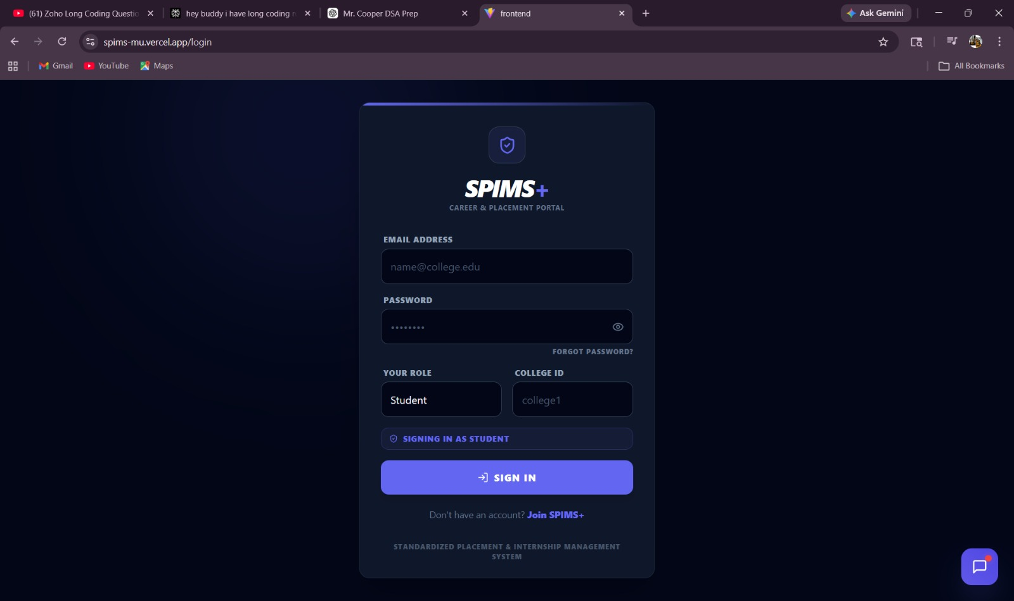
Figure 9.1 : Login Page
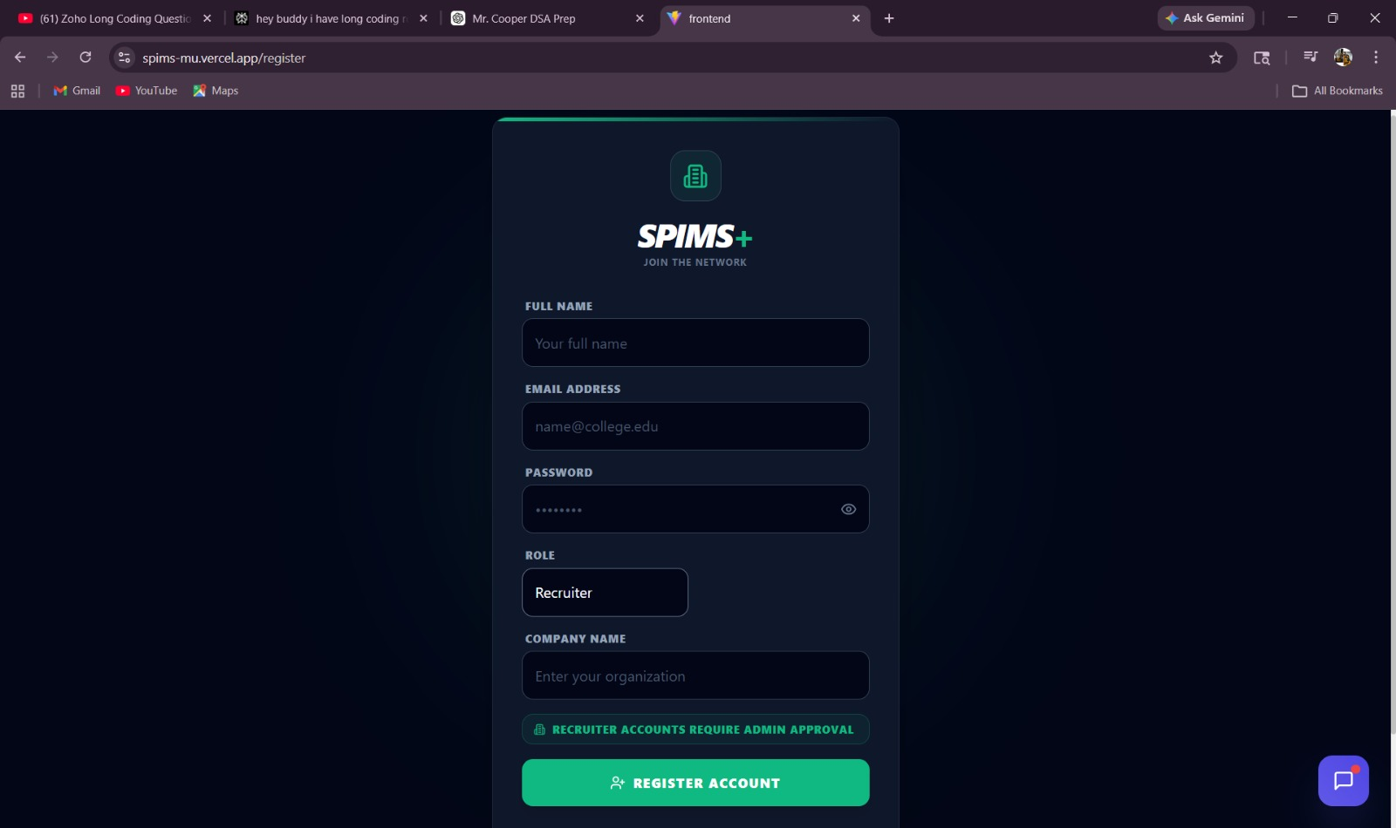
Figure 9.2 : Signup Page
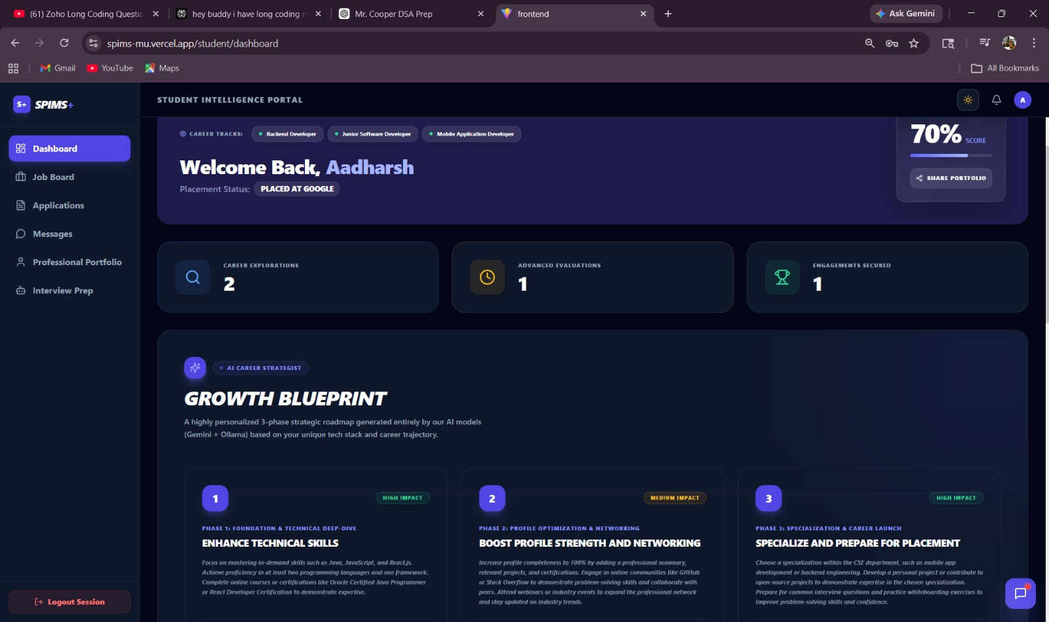
Figure 9.3 :Student Dashboard
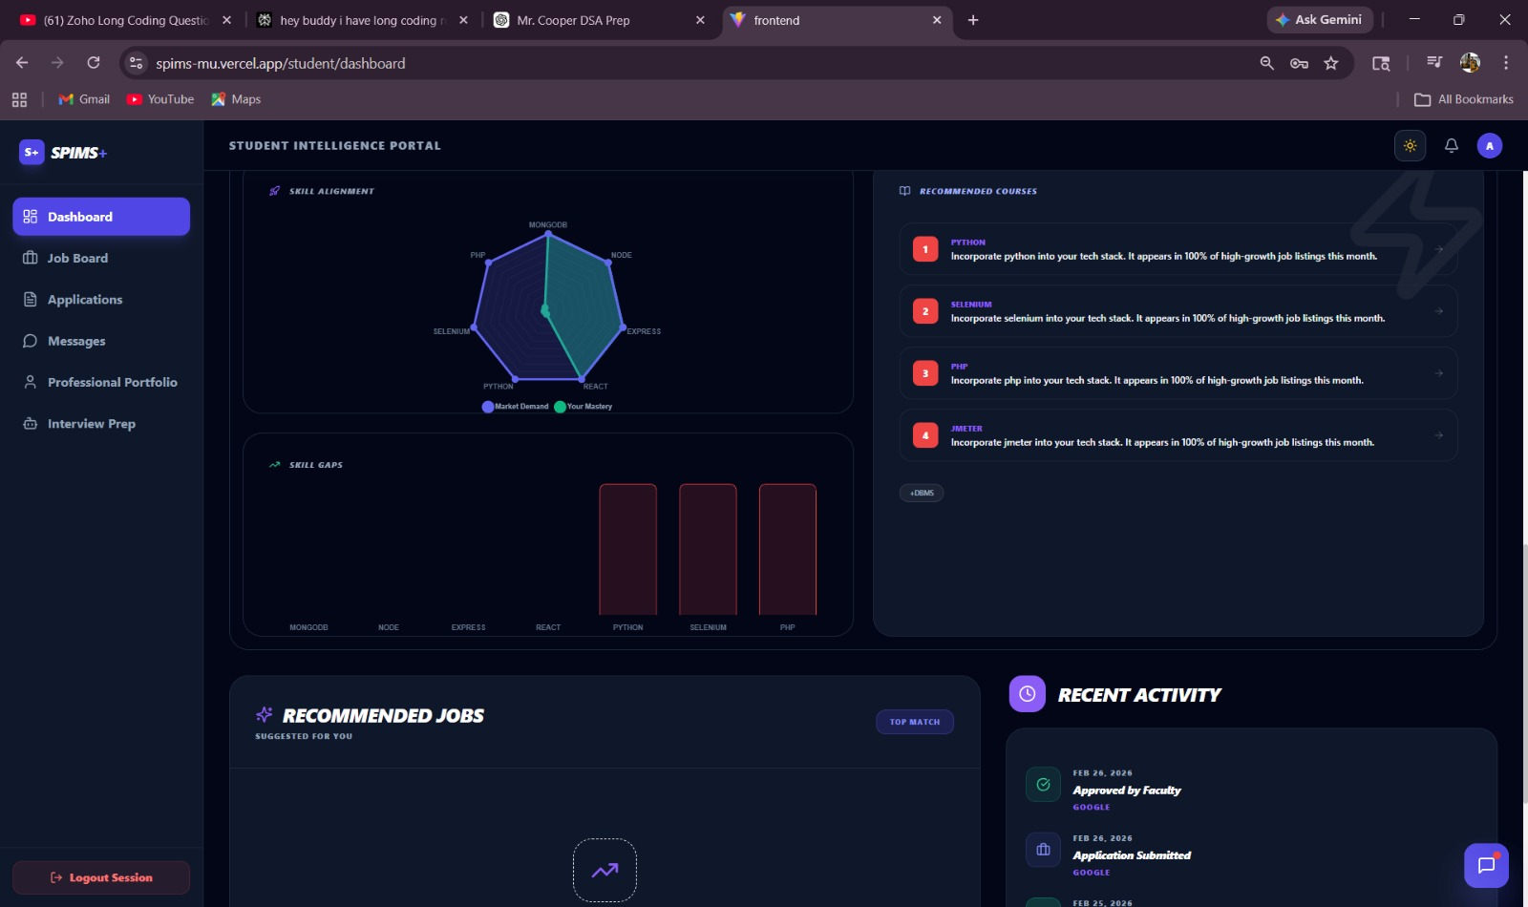
Figure 9.4 : Student Dashboard
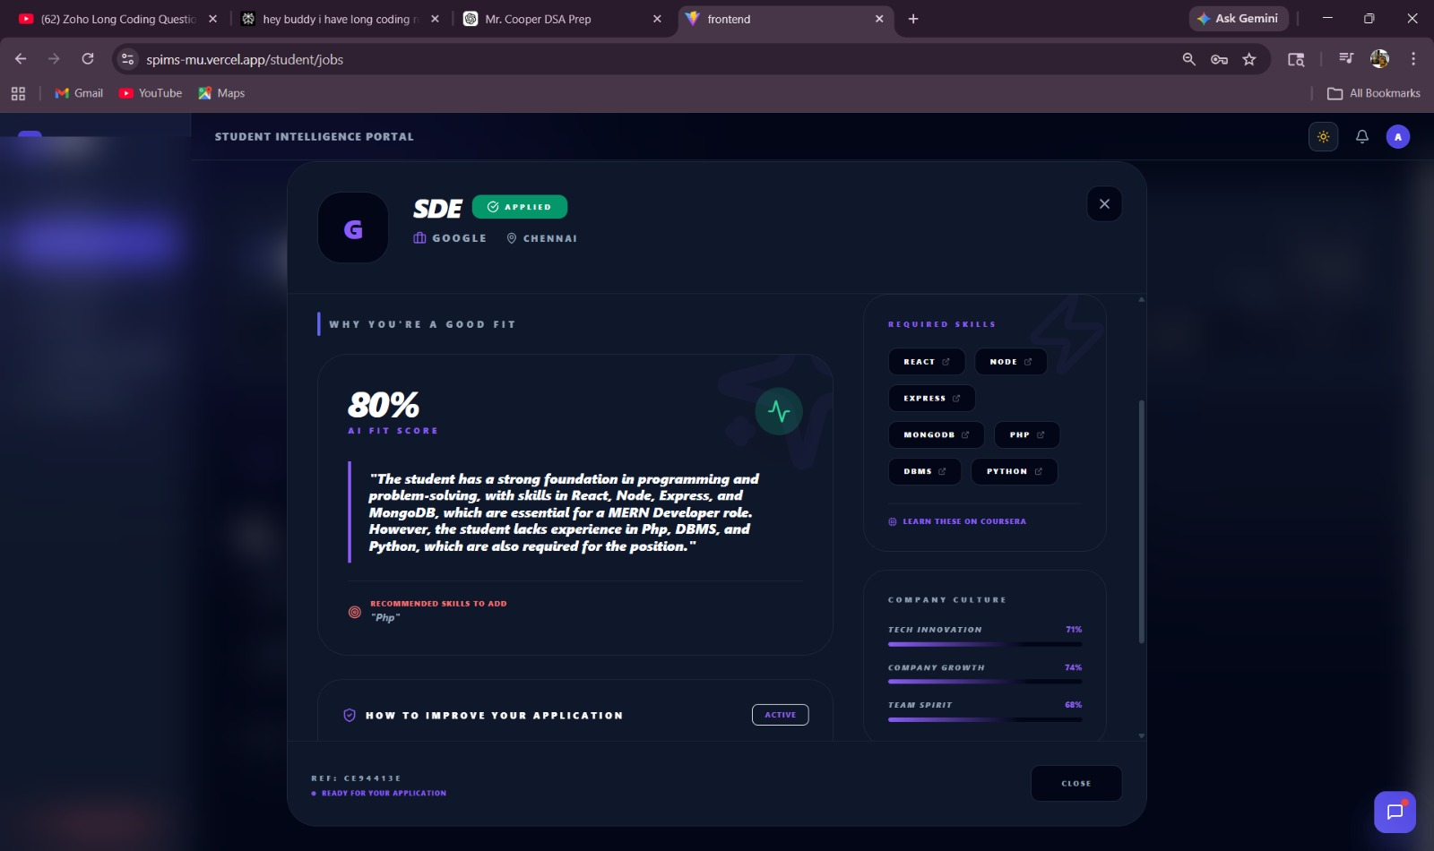
Figure 9.5 : Job Matching
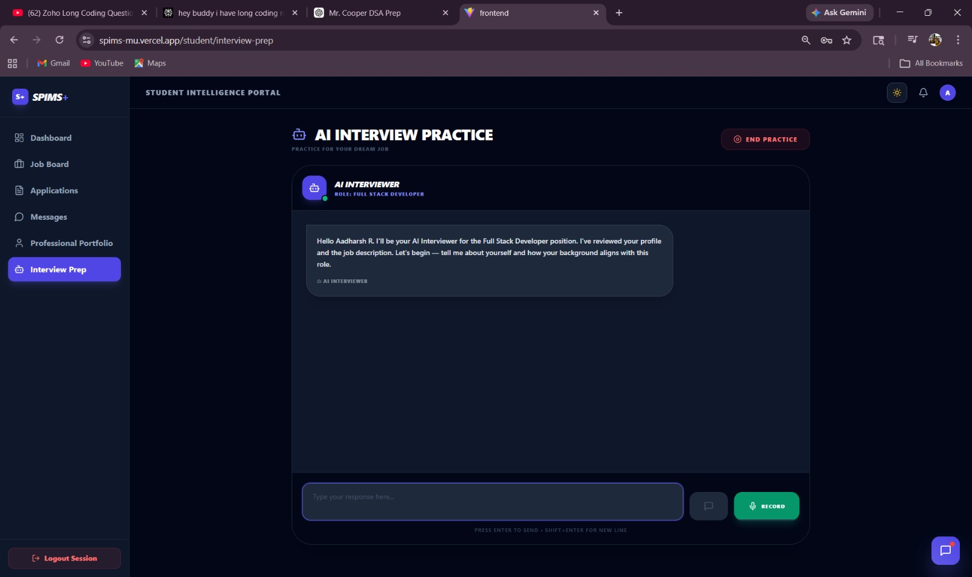
Figure 9.6 : AI interview Prep
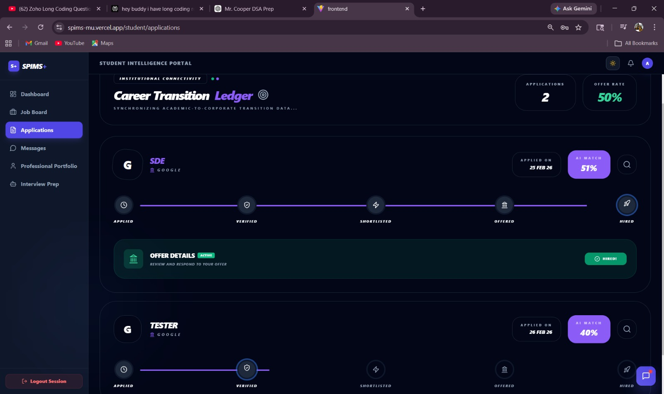
Figure 9.7 : Job Application
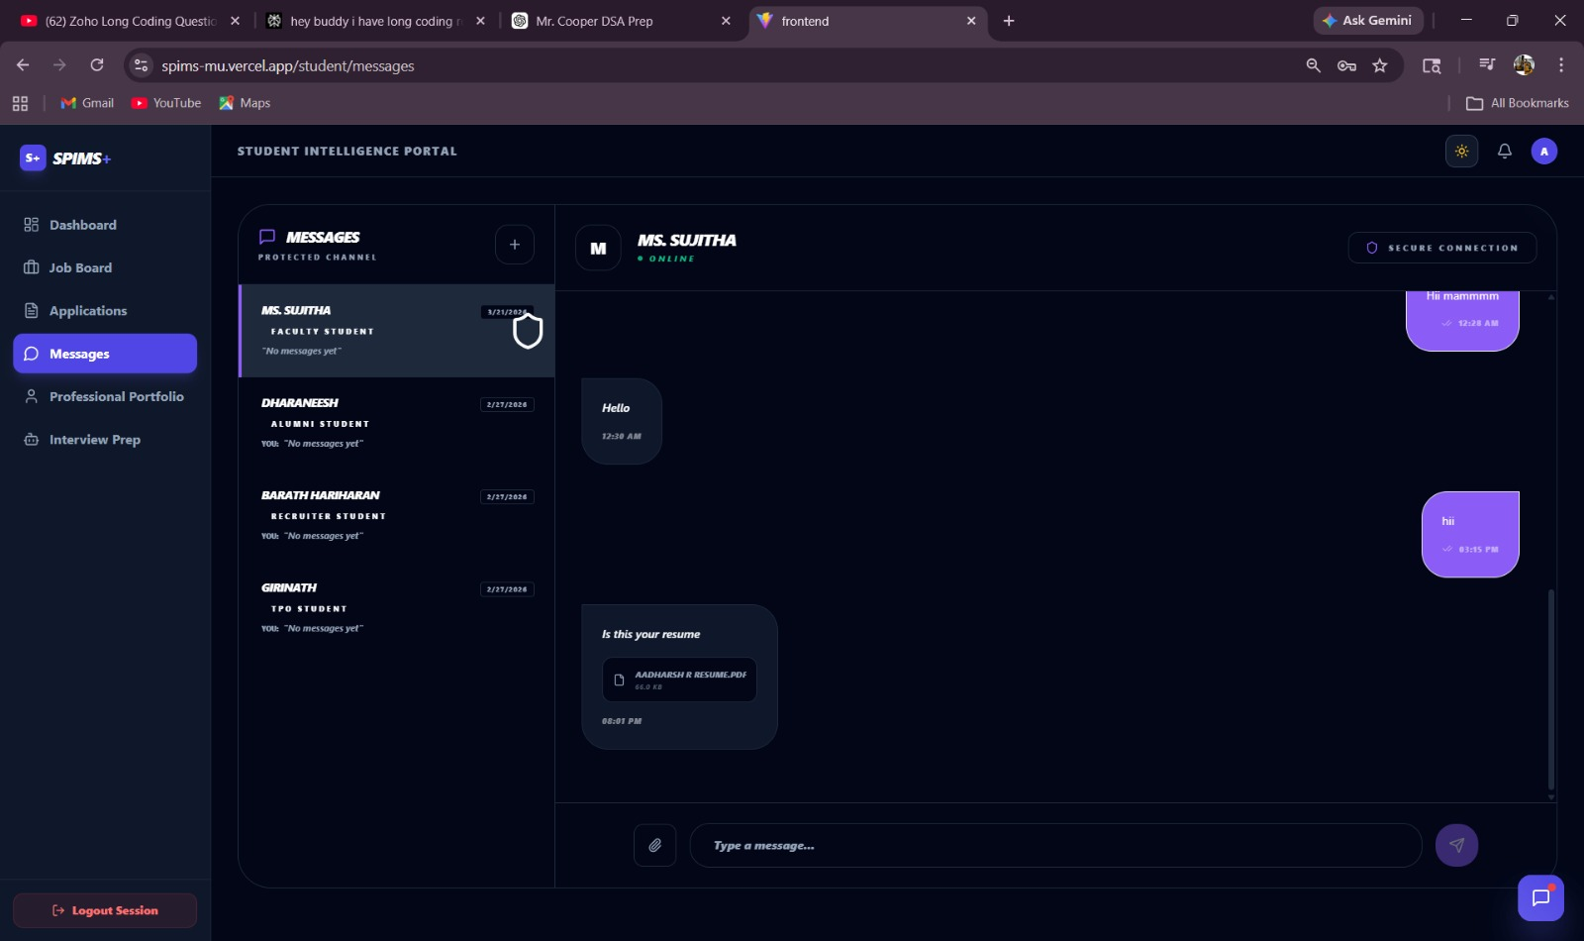
Figure 9.8 : Message Interface
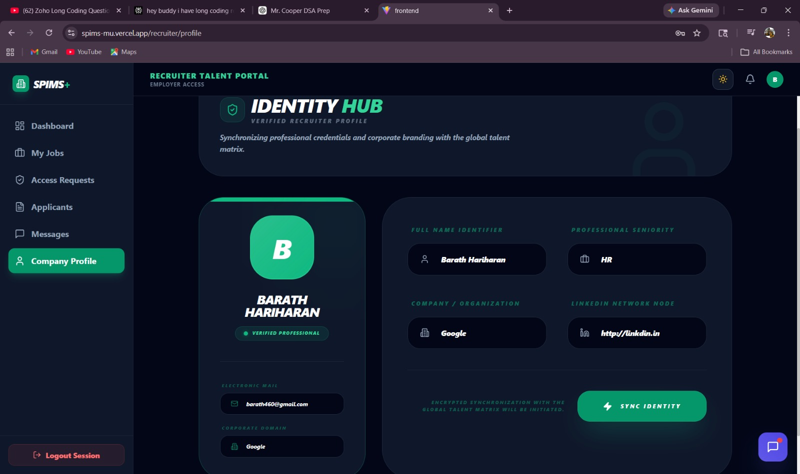
Figure 9.9 Recruiter Profile
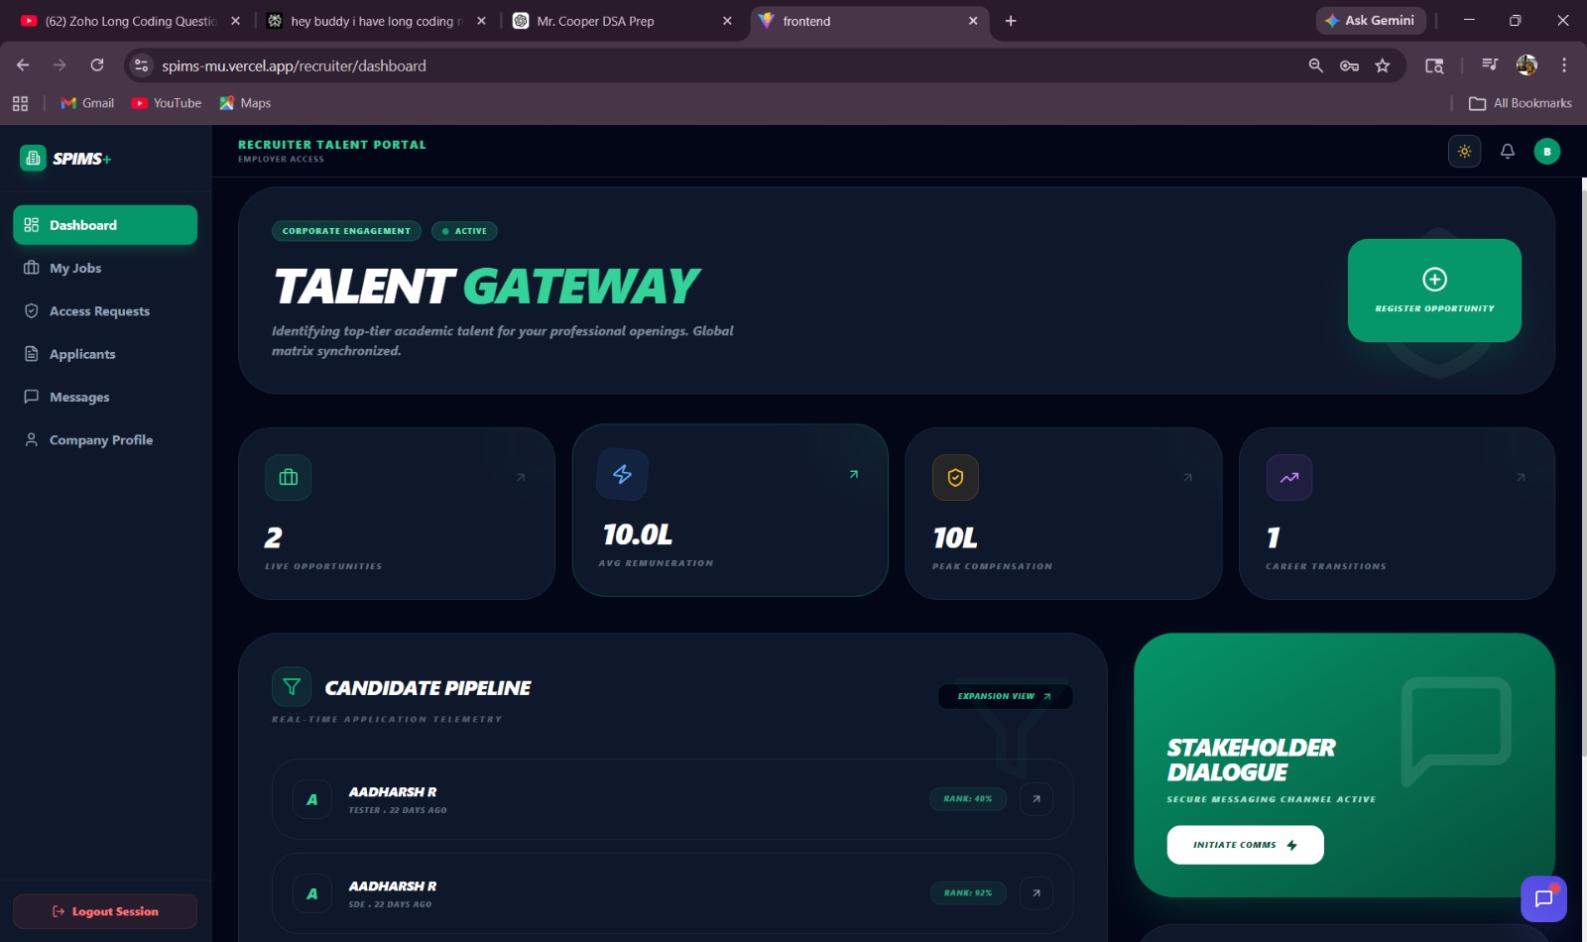
Figure 9.10 Recruiter Dashboard
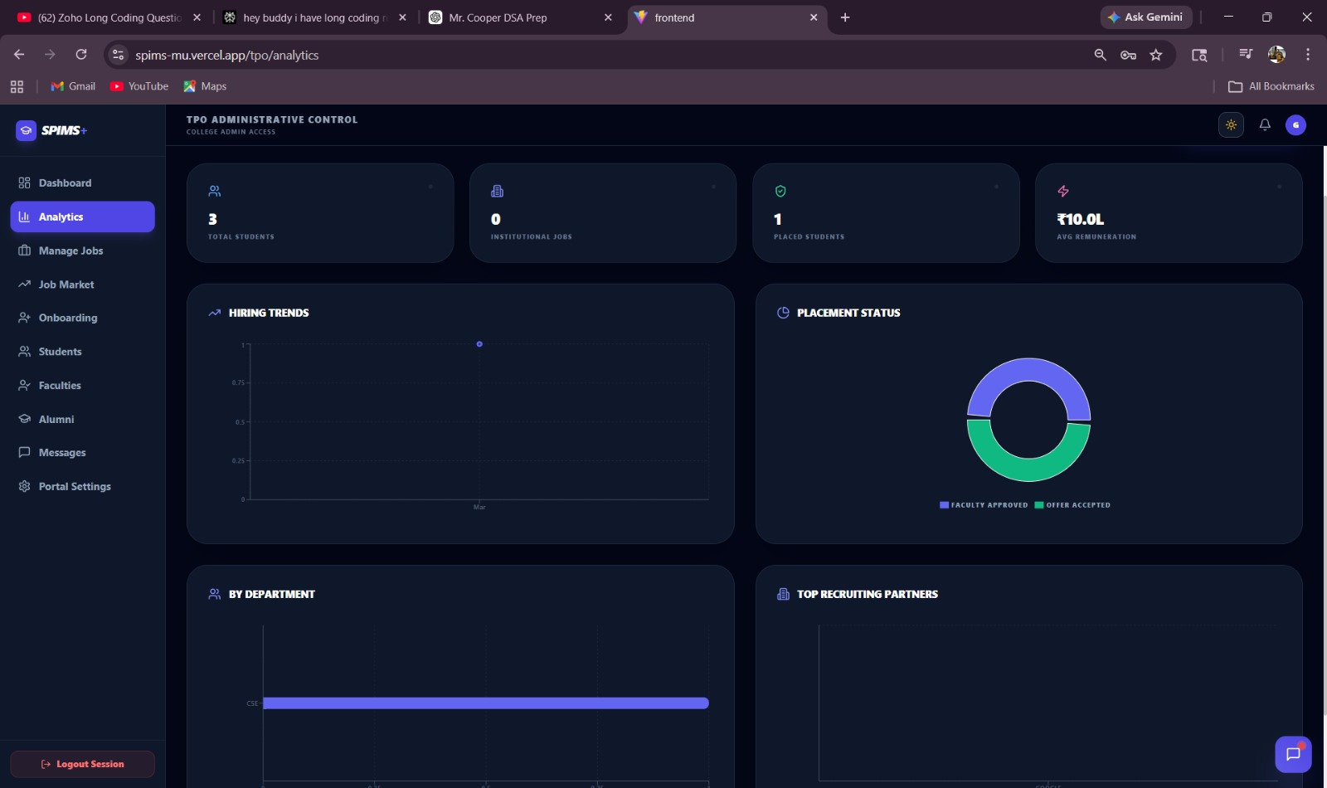
Figure 9.11 TPO Analytics
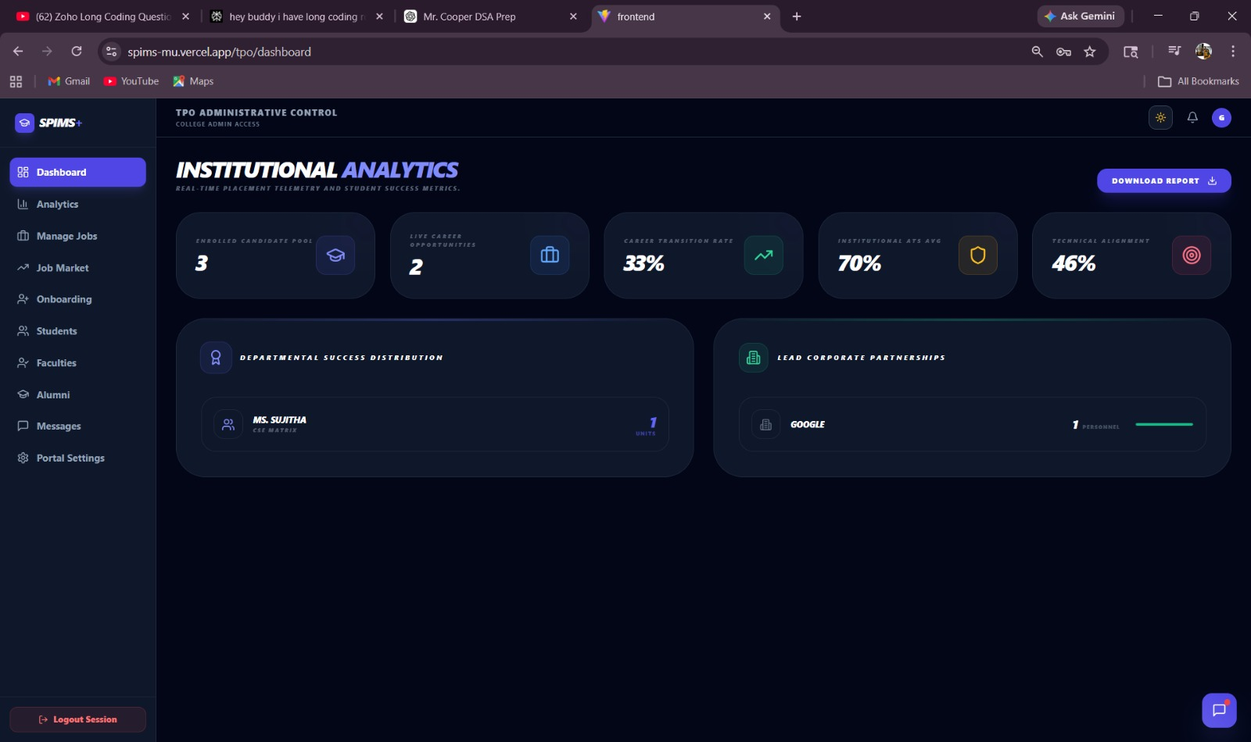
Figure 9.12 TPO Dashboard
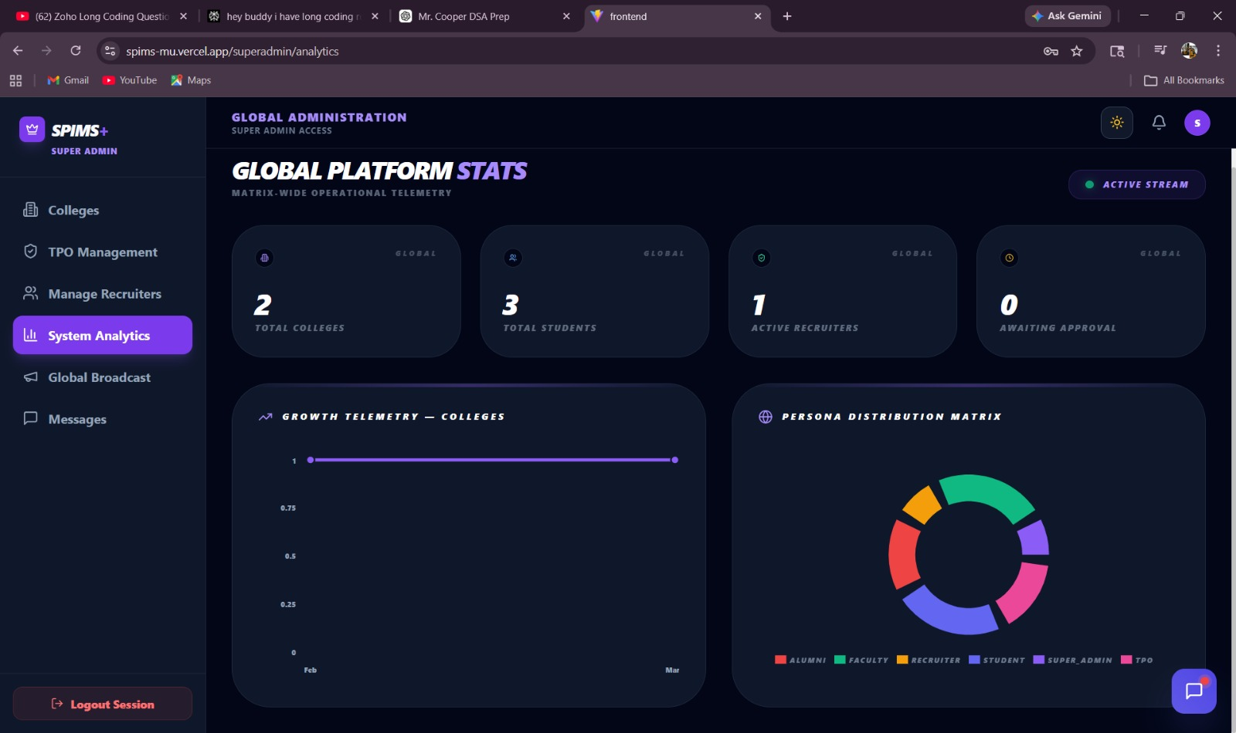
Figure 9.13 SuperAdmin Analytics

APPENDICES
APPENDIX – I
TPODashboard.jsx
import { useState, useEffect } from 'react';
import { dashboardApi } from '../../api/api';
import { toast } from 'react-hot-toast';
import {
Users, Briefcase, TrendingUp, Download,
Building2, GraduationCap, Award, Shield, Target
} from 'lucide-react';

const TPODashboard = () => {
const [stats, setStats] = useState({
studentCount: 0,
jobCount: 0,
placementRate: '0%',
avgAtsScore: 0,
avgJobMatch: 0,
placementsByFaculty: [],
companiesByHires: []
});
const [loading, setLoading] = useState(true);

useEffect(() => {
dashboardApi.getTpoDashboard()
.then(res => setStats(res.data))
.catch(err => console.error('Failed to fetch TPO stats', err))
.finally(() => setLoading(false));
}, []);

const handleExport = async () => {
try {
const res = await dashboardApi.exportTpoData();
const url = window.URL.createObjectURL(new Blob([res.data]));
const link = document.createElement('a');
link.href = url;
link.setAttribute('download', 'TPO_Export_Data.csv');
document.body.appendChild(link);
link.click();
toast.success('Placement data downloaded');
} catch (err) {
toast.error('Download failed. Please try again.');
}
};

if (loading) return (
<div className="flex flex-col items-center justify-center min-h-[400px] gap-6">
<div className="relative">
<div className="h-16 w-16 rounded-2xl border-4 border-indigo-500/10 border-t-indigo-500 animate-spin shadow-[var(--shadow-md)]"></div>
<div className="absolute inset-0 flex items-center justify-center">
<div className="h-6 w-6 bg-indigo-500 rounded-lg animate-pulse"></div>
</div>
</div>
<p className="text-[10px] font-black text-indigo-500 uppercase tracking-[0.3em] animate-pulse italic">Synchronizing Institutional Matrix...</p>
</div>
);

return (
<div className="space-y-8 animate-in fade-in duration-700">
{/* Header */}
<header className="flex flex-col md:flex-row justify-between items-start md:items-end gap-4">
<div>
<h1 className="text-3xl md:text-4xl font-black text-[var(--text-bright)] uppercase tracking-tighter italic">
Institutional <span className="text-indigo-400">Analytics</span>
</h1>
<p className="text-[var(--text-muted)] text-[10px] font-black uppercase tracking-[0.2em] mt-1 opacity-60 italic">
Real-time placement telemetry and student success metrics.
</p>
</div>
<button
onClick={handleExport}
className="bg-indigo-600 text-white px-6 py-3 rounded-2xl font-black uppercase tracking-widest text-xs hover:bg-indigo-500 transition-all shadow-xl shadow-indigo-600/20 flex items-center gap-3 group active:scale-95 shrink-0"
>
Download Report
<Download size={16} className="group-hover:translate-y-0.5 transition-transform" />
</button>
</header>

{/* Core Stats Grid */}
<div className="grid grid-cols-1 md:grid-cols-3 xl:grid-cols-5 gap-6">
{[
{ label: 'Enrolled Candidate Pool', value: stats.studentCount, icon: GraduationCap, color: 'text-indigo-400', bg: 'bg-indigo-500/10', border: 'border-indigo-500/20' },
{ label: 'Live Career Opportunities', value: stats.jobCount, icon: Briefcase, color: 'text-blue-400', bg: 'bg-blue-500/10', border: 'border-blue-500/20' },
{ label: 'Career Transition Rate', value: stats.placementRate, icon: TrendingUp, color: 'text-emerald-400', bg: 'bg-emerald-500/10', border: 'border-emerald-500/20' },
{ label: 'Institutional ATS Avg', value: `${stats.avgAtsScore}%`, icon: Shield, color: 'text-amber-400', bg: 'bg-amber-500/10', border: 'border-amber-500/20' },
{ label: 'Technical Alignment', value: `${stats.avgJobMatch}%`, icon: Target, color: 'text-rose-400', bg: 'bg-rose-500/10', border: 'border-rose-500/20' },
].map((stat, i) => (
<div key={i} className="bg-[var(--bg-card)] border border-[var(--border-main)] p-8 rounded-[2.5rem] flex items-center justify-between group hover:border-indigo-500/30 transition-all duration-500 shadow-[var(--shadow-lg)] relative overflow-hidden">
<div className="absolute top-0 right-0 -mr-8 -mt-8 w-24 h-24 bg-indigo-500/5 rounded-full blur-2xl group-hover:bg-indigo-500/10 transition-all duration-700 pointer-events-none" />
<div className="relative z-10">
<p className="text-[9px] font-black text-[var(--text-muted)] uppercase tracking-[0.3em] mb-2 opacity-50 italic">{stat.label}</p>
<p className="text-4xl font-black text-[var(--text-bright)] tracking-tighter uppercase italic group-hover:translate-x-1 transition-transform duration-500">{stat.value}</p>
</div>
<div className={`relative z-10 w-16 h-16 rounded-2xl flex items-center justify-center border ${stat.bg} ${stat.border} shadow-[var(--shadow-md)] group-hover:scale-110 group-hover:rotate-6 transition-all duration-500`}>
<stat.icon className={`w-8 h-8 ${stat.color}`} />
</div>
</div>
))}
</div>

<div className="grid grid-cols-1 lg:grid-cols-2 gap-8">
{/* Faculty Performance */}
<div className="bg-[var(--bg-card)] rounded-[3rem] p-10 border border-[var(--border-main)] shadow-[var(--shadow-lg)] relative overflow-hidden group">
<div className="absolute top-0 left-0 w-full h-1 bg-gradient-to-r from-transparent via-indigo-500/30 to-transparent" />
<div className="flex items-center gap-4 mb-10">
<div className="w-12 h-12 bg-indigo-500/10 rounded-2xl flex items-center justify-center text-indigo-400 border border-indigo-500/20 shadow-[var(--shadow-sm)] group-hover:scale-110 transition-transform duration-500">
<Award size={24} />
</div>
<h2 className="text-[11px] font-black text-[var(--text-bright)] uppercase tracking-[0.3em] italic">Departmental Success Distribution</h2>
</div>
<div className="space-y-5">
{stats.placementsByFaculty?.map((f, i) => (
<div key={i} className="flex items-center justify-between p-5 bg-[var(--bg-main)]/50 rounded-3xl border border-[var(--border-main)] hover:border-indigo-500/30 transition-all duration-500 group/item shadow-[var(--shadow-sm)]">
<div className="flex items-center gap-4">
<div className="w-12 h-12 rounded-2xl bg-[var(--bg-card)] border border-[var(--border-main)] flex items-center justify-center text-indigo-400 group-hover/item:scale-110 transition-all shadow-[var(--shadow-sm)]">
<Users size={22} />
</div>
<div className="flex flex-col">
<span className="text-sm font-black text-[var(--text-bright)] uppercase tracking-tight italic group-hover/item:text-indigo-400 transition-colors">{f.facultyName || 'Institutional Direct'}</span>
<span className="text-[9px] text-[var(--text-muted)] font-black uppercase tracking-[0.2em] opacity-50 italic">{f.department} Matrix</span>
</div>
</div>
<div className="text-right">
<p className="text-2xl font-black text-indigo-500 italic tracking-tighter">{f.placedCount}</p>
<p className="text-[8px] font-black text-indigo-500/50 uppercase tracking-[0.2em] leading-none">Units</p>
</div>
</div>
))}
{(!stats.placementsByFaculty || stats.placementsByFaculty.length === 0) && (
<div className="flex flex-col items-center justify-center py-16 opacity-30 select-none">
<Users size={40} className="text-[var(--text-muted)] mb-4" />
<p className="text-[10px] font-black uppercase tracking-[0.3em] italic">No departmental telemetry available</p>
</div>
)}
</div>
</div>

{/* Top Companies */}
<div className="bg-[var(--bg-card)] rounded-[3rem] p-10 border border-[var(--border-main)] shadow-[var(--shadow-lg)] relative overflow-hidden group">
<div className="absolute top-0 left-0 w-full h-1 bg-gradient-to-r from-transparent via-emerald-500/30 to-transparent" />
<div className="flex items-center gap-4 mb-10">
<div className="w-12 h-12 bg-emerald-500/10 rounded-2xl flex items-center justify-center text-emerald-400 border border-emerald-500/20 shadow-[var(--shadow-sm)] group-hover:scale-110 transition-transform duration-500">
<Building2 size={24} />
</div>
<h2 className="text-[11px] font-black text-[var(--text-bright)] uppercase tracking-[0.3em] italic">Lead Corporate Partnerships</h2>
</div>
<div className="space-y-5">
{stats.companiesByHires?.slice(0, 5).map((company, i) => (
<div key={i} className="p-5 rounded-3xl bg-[var(--bg-main)]/50 border border-[var(--border-main)] flex items-center justify-between hover:border-emerald-500/30 transition-all duration-500 group/item shadow-[var(--shadow-sm)]">
<div className="flex items-center gap-4">
<div className="w-12 h-12 rounded-2xl bg-[var(--bg-card)] border border-[var(--border-main)] flex items-center justify-center shadow-[var(--shadow-sm)] group-hover/item:scale-110 transition-all">
<Building2 size={20} className="text-[var(--text-muted)] opacity-60" />
</div>
<h4 className="font-black text-[var(--text-bright)] uppercase tracking-tight text-sm italic group-hover/item:text-emerald-400 transition-colors">{company.company}</h4>
</div>
<div className="flex items-center gap-6">
<div className="text-right">
<span className="text-xl font-black text-[var(--text-bright)] italic tracking-tighter">{company.hiresCount}</span>
<span className="text-[9px] font-black text-[var(--text-muted)] ml-2 uppercase tracking-widest opacity-40">Personnel</span>
</div>
<div className="h-1.5 w-24 bg-[var(--bg-main)] rounded-full overflow-hidden border border-[var(--border-main)] shadow-inner">
<div
className="h-full bg-emerald-500 rounded-full shadow-[0_0_10px_rgba(16,185,129,0.5)] transition-all duration-1000"
style={{ width: `${(company.hiresCount / (stats.companiesByHires[0]?.hiresCount || 1)) * 100}%` }}
/>
</div>
</div>
</div>
))}
{(!stats.companiesByHires || stats.companiesByHires.length === 0) && (
<div className="flex flex-col items-center justify-center py-16 opacity-30 select-none">
<Building2 size={40} className="text-[var(--text-muted)] mb-4" />
<p className="text-[10px] font-black uppercase tracking-[0.3em] italic">No corporate hiring telemetry</p>
</div>
)}
</div>
</div>
</div>
</div>
);
};

export default TPODashboard;
RecruiterDashboard.jsx
import React, { useState, useEffect } from 'react';
import { dashboardApi } from '../../api/api';
import {
Briefcase, Zap, TrendingUp, MessageSquare,
ArrowUpRight, ShieldCheck, PlusCircle, Filter
} from 'lucide-react';
import { Link } from 'react-router-dom';
import moment from 'moment';

const RecruiterDashboard = () => {
const [stats, setStats] = useState({
activeJobs: 0, totalCandidates: 0,
shortlistedCount: 0, avgCTC: 0, highestCTC: 0
});
const [recentApplicants, setRecentApplicants] = useState([]);
const [loading, setLoading] = useState(true);

const fetchDashboardData = async () => {
try {
const { data } = await dashboardApi.getRecruiterStats();
setStats(data);
setRecentApplicants(data.recentApplicants);
} catch (error) {
console.error('Failed to load dashboard data');
} finally {
setLoading(false);
}
};

useEffect(() => { fetchDashboardData(); }, []);

if (loading) return (
<div className="flex flex-col items-center justify-center min-h-[400px] gap-6">
<div className="relative">
<div className="h-16 w-16 rounded-2xl border-4 border-emerald-500/10 border-t-emerald-500 animate-spin shadow-[var(--shadow-md)]"></div>
<div className="absolute inset-0 flex items-center justify-center">
<div className="h-6 w-6 bg-emerald-500 rounded-lg animate-pulse"></div>
</div>
</div>
<p className="text-[10px] font-black text-emerald-500 uppercase tracking-[0.3em] animate-pulse italic">Synchronizing Talent Matrix...</p>
</div>
);

return (
<div className="space-y-10 pb-12 animate-in fade-in duration-700">
{/* Header Section */}
<div className="bg-[var(--bg-card)] border border-[var(--border-main)] rounded-[3rem] p-10 text-[var(--text-bright)] relative overflow-hidden shadow-[var(--shadow-xl)] group">
<div className="absolute top-0 right-0 p-10 opacity-5 pointer-events-none group-hover:scale-110 group-hover:text-emerald-500 transition-all duration-700">
<ShieldCheck size={200} />
</div>
<div className="relative z-10 flex flex-col lg:flex-row lg:items-center justify-between gap-8">
<div className="space-y-5 flex-1">
<div className="flex items-center gap-3">
<span className="px-3 py-1 bg-emerald-500/20 border border-emerald-400/20 rounded-full text-[10px] font-black uppercase tracking-widest text-emerald-300">
Corporate Engagement
</span>
<div className="flex items-center gap-2 px-3 py-1 bg-emerald-500/20 border border-emerald-400/20 rounded-full">
<div className="w-2 h-2 rounded-full bg-emerald-500 animate-pulse" />
<span className="text-[9px] font-black text-emerald-300 uppercase tracking-widest">Active</span>
</div>
</div>
<div className="space-y-4">
<h1 className="text-4xl md:text-6xl font-black tracking-tighter leading-none text-[var(--text-bright)] uppercase italic">
Talent <span className="text-emerald-400">Gateway</span>
</h1>
<p className="text-[var(--text-muted)] text-sm md:text-base font-bold max-w-xl leading-relaxed italic opacity-80">
Identifying top-tier academic talent for your professional openings. Global matrix synchronized.
</p>
</div>
</div>

<Link
to="/recruiter/jobs/new"
className="p-8 bg-emerald-600 hover:bg-emerald-500 rounded-3xl border border-emerald-400/20 shadow-2xl shadow-emerald-600/30 transition-all flex flex-col items-center justify-center min-w-[200px] group/btn active:scale-95"
>
<PlusCircle size={32} className="text-white mb-3 group-hover/btn:scale-110 group-hover/btn:rotate-6 transition-transform" />
<span className="text-[10px] font-black uppercase tracking-widest text-emerald-100 italic text-center">Register Opportunity</span>
</Link>
</div>
</div>

{/* Stats Grid */}
<div className="grid grid-cols-1 sm:grid-cols-2 lg:grid-cols-4 gap-5">
{[
{ label: 'Live Opportunities', value: stats.activeJobs, icon: Briefcase, color: 'text-emerald-400', bg: 'bg-emerald-500/10', border: 'border-emerald-500/20' },
{ label: 'Avg Remuneration', value: `${stats.avgCTC || 0}L`, icon: Zap, color: 'text-blue-400', bg: 'bg-blue-500/10', border: 'border-blue-500/10' },
{ label: 'Peak Compensation', value: `${stats.highestCTC || 0}L`, icon: ShieldCheck, color: 'text-amber-400', bg: 'bg-amber-500/10', border: 'border-amber-500/20' },
{ label: 'Career Transitions', value: stats.shortlistedCount, icon: TrendingUp, color: 'text-purple-400', bg: 'bg-purple-500/10', border: 'border-purple-500/20' }
].map((stat, i) => (
<div
key={i}
className="bg-[var(--bg-card)] border border-[var(--border-main)] p-8 rounded-[2.5rem] flex flex-col gap-6 group hover:border-emerald-500/30 hover:-translate-y-1 transition-all duration-500 shadow-[var(--shadow-lg)] relative overflow-hidden"
>
<div className="absolute top-0 right-0 -mr-8 -mt-8 w-24 h-24 bg-emerald-500/5 rounded-full blur-2xl group-hover:bg-emerald-500/10 transition-all duration-700 pointer-events-none" />
<div className="flex justify-between items-center relative z-10">
<div className={`w-14 h-14 rounded-2xl flex items-center justify-center border shadow-[var(--shadow-sm)] group-hover:scale-110 group-hover:rotate-6 transition-all duration-500 ${stat.bg} ${stat.border} ${stat.color}`}>
<stat.icon size={24} />
</div>
<ArrowUpRight size={18} className="text-[var(--text-muted)] opacity-30 group-hover:text-emerald-400 group-hover:opacity-100 transition-all" />
</div>
<div className="relative z-10">
<h3 className="text-4xl font-black text-[var(--text-bright)] tracking-tighter tabular-nums leading-none uppercase italic group-hover:translate-x-1 transition-transform duration-500">{stat.value}</h3>
<p className="text-[10px] font-black text-[var(--text-muted)] uppercase tracking-[0.2em] mt-3 italic opacity-60">{stat.label}</p>
</div>
</div>
))}
</div>

{/* Main Content */}
<div className="grid grid-cols-1 lg:grid-cols-3 gap-8">
{/* Candidate Pipeline */}
<div className="lg:col-span-2">
<div className="bg-[var(--bg-card)] border border-[var(--border-main)] rounded-[3rem] p-10 shadow-[var(--shadow-xl)] relative overflow-hidden h-full">
<div className="absolute top-0 right-0 p-10 opacity-5 pointer-events-none group-hover:scale-110 transition-all">
<Filter size={150} className="text-emerald-500" />
</div>
<div className="flex items-center justify-between mb-10">
<div>
<h2 className="text-2xl font-black text-[var(--text-bright)] uppercase tracking-tight flex items-center gap-4 italic">
<div className="w-12 h-12 bg-emerald-500/10 rounded-2xl flex items-center justify-center text-emerald-500 border border-emerald-500/20">
<Filter size={24} />
</div>
Candidate Pipeline
</h2>
<p className="text-[10px] font-black text-[var(--text-muted)] uppercase tracking-[0.3em] mt-2 italic opacity-50">Real-time application telemetry</p>
</div>
<Link
to="/recruiter/applications"
className="px-6 py-2 bg-[var(--bg-main)] text-emerald-400 text-[9px] font-black uppercase tracking-widest rounded-xl border border-emerald-500/20 hover:bg-emerald-500/10 transition-all flex items-center gap-2 italic"
>
Expansion View <ArrowUpRight size={14} />
</Link>
</div>

<div className="space-y-4">
{recentApplicants.length === 0 ? (
<div className="py-20 text-center opacity-40">
<div className="w-16 h-16 bg-[var(--bg-main)] rounded-[1.5rem] border border-[var(--border-main)] flex items-center justify-center mx-auto mb-5 shadow-[var(--shadow-sm)]">
<Briefcase size={24} className="text-[var(--text-muted)]" />
</div>
<p className="text-[10px] font-black uppercase tracking-[0.3em] text-[var(--text-muted)] italic">No active candidates detected</p>
</div>
) : (
recentApplicants.map((app, i) => (
<div key={i} className="flex items-center justify-between p-6 bg-[var(--bg-main)]/50 border border-[var(--border-main)] hover:border-emerald-500/30 rounded-[2rem] transition-all group/item shadow-[var(--shadow-sm)] relative overflow-hidden">
<div className="absolute top-0 left-0 w-1 h-full bg-emerald-500 opacity-0 group-hover/item:opacity-100 transition-opacity" />
<div className="flex items-center gap-5 min-w-0">
<div className="w-12 h-12 shrink-0 bg-[var(--bg-card)] border border-[var(--border-main)] rounded-2xl flex items-center justify-center text-emerald-400 group-hover/item:scale-110 group-hover/item:bg-emerald-500 group-hover/item:text-white transition-all font-black text-lg shadow-[var(--shadow-sm)] italic">
{app.studentName?.charAt(0)}
</div>
<div className="min-w-0">
<h4 className="text-base font-black text-[var(--text-bright)] truncate uppercase tracking-tight italic group-hover/item:text-emerald-400 transition-colors">{app.studentName}</h4>
<p className="text-[9px] text-[var(--text-muted)] font-black uppercase tracking-widest truncate opacity-60 italic mt-1">{app.jobTitle} • {moment(app.appliedAt).fromNow()}</p>
</div>
</div>
<div className="flex items-center gap-4 shrink-0">
<span className="px-4 py-1.5 bg-emerald-500/10 text-emerald-400 rounded-xl text-[9px] font-black uppercase tracking-widest border border-emerald-500/20 shadow-[var(--shadow-sm)] italic animate-pulse">
Rank: {app.aiScores?.layer3RecruiterRank || app.aiScores?.layer1StudentMatch || 0}%
</span>
<Link to="/recruiter/applications" className="w-10 h-10 bg-[var(--bg-card)] text-[var(--text-muted)] hover:text-emerald-400 rounded-xl border border-[var(--border-main)] hover:border-emerald-500/30 transition-all flex items-center justify-center shadow-[var(--shadow-sm)] active:scale-90">
<ArrowUpRight size={16} />
</Link>
</div>
</div>
))
)}
</div>
</div>
</div>

{/* Right Column */}
<div className="space-y-8">
{/* Messages CTA */}
<div className="bg-gradient-to-br from-emerald-600 to-emerald-900 rounded-[3rem] p-10 text-white shadow-2xl shadow-emerald-600/30 group relative overflow-hidden min-h-[320px] flex flex-col justify-end">
<div className="absolute top-0 right-0 p-10 opacity-10 group-hover:scale-110 transition-transform duration-700 pointer-events-none">
<MessageSquare size={160} />
</div>
<div className="relative z-10 space-y-6">
<div>
<h3 className="text-3xl font-black uppercase tracking-tighter leading-none italic">Stakeholder <br /> Dialogue</h3>
<p className="text-emerald-100 text-[10px] font-black uppercase tracking-[0.2em] mt-3 opacity-80 italic">Secure messaging channel active</p>
</div>
<Link
to="/recruiter/messages"
className="inline-flex items-center gap-3 px-8 py-4 bg-white text-emerald-900 rounded-2xl text-[10px] font-black uppercase tracking-widest hover:shadow-2xl hover:scale-105 active:scale-95 italic transition-all group/btn"
>
Initiate Comms <Zap size={14} className="fill-current group-hover:scale-125 transition-transform" />
</Link>
</div>
</div>

{/* Action Items */}
<div className="bg-[var(--bg-card)] border border-[var(--border-main)] rounded-[3rem] p-10 shadow-[var(--shadow-xl)] relative overflow-hidden">
<div className="flex items-center justify-between mb-8">
<h3 className="text-[10px] font-black text-[var(--text-bright)] uppercase tracking-[0.3em] italic">Operational Tasks</h3>
<div className="w-8 h-8 bg-indigo-500/10 rounded-xl flex items-center justify-center text-indigo-400 border border-indigo-500/20">
<ShieldCheck size={14} />
</div>
</div>
<div className="space-y-4">
<Link
to="/recruiter/requests"
className="flex items-center gap-5 p-6 bg-[var(--bg-main)]/50 border border-[var(--border-main)] rounded-2xl hover:border-emerald-500/30 transition-all group/task shadow-[var(--shadow-sm)]"
>
<div className="w-12 h-12 rounded-xl bg-emerald-500/10 text-emerald-400 flex items-center justify-center shrink-0 border border-emerald-500/20 group-hover/task:scale-110 transition-transform shadow-[var(--shadow-sm)]">
<ShieldCheck size={20} />
</div>
<div className="min-w-0">
<p className="text-[10px] text-[var(--text-bright)] font-black uppercase tracking-tight italic group-hover/task:text-emerald-400 transition-colors">Access Credentials</p>
<p className="text-[8px] text-[var(--text-muted)] font-black uppercase mt-1 opacity-60 italic">{stats.pendingApprovals || 0} Awaiting Verification</p>
</div>
</Link>
</div>
</div>
</div>
</div>
</div>
);
};

export default RecruiterDashboard;


SUSTAINABLE DEVELOPMENT GOALS MAPPING

The Sustainable Development Goals are a collection of 17 global goals designed to blue print to achieve a better and more sustainable future for all. The SDGs, set in 2015 by the United Nations General Assembly and intended to be achieved by the year 2030, In 2015, 195 nations agreed as a blue print that they can change the world for the better. The project is based on one of the 17 goals.

Questions | Answer Samples
Which SDGs does the project directly address? | SDG 8 – Decent Work & Economic Growth; SDG 4 – Quality Education (targets 4.4, 8.6)
What strategies or actions are being implemented to achieve these goals? | AI skill matching, automated eligibility verification, real-time placement analytics
How is progress measured and reported in relation to the SDGs? | Placement conversion rates, skill matching accuracy, drive completion metrics
How were these goals identified as relevant to the project’s objectives? | Campus placements directly impact graduate employability aligning with SDG youth employment targets
Are there any partnerships or collaborations in place to enhance this impact? | Integration potential with college ERPs and company HR systems

REFERENCES
Title: "Campus Placement Management System with Role"​
Authors: Not specified
Published in: ScienceXcel Journal, 2026
Pages: N/A DOI: N/A​
Title: "Smart Placement Prediction & Recommendation System"​
Authors: Not specified
Published in: RJWAVE International Journal, 2026
Pages: N/A DOI: N/A​
Title: "Smart Hire: AI-Based Campus Recruitment System"​
Authors: Not specified
Published in: International Journal for Innovative Research in Technology (IJIRT), 2025
Pages: N/A DOI: N/A​
Title: "Placement Cell Management System"​
Authors: FreeProjectz Team
Published in: Spring Boot ReactJS Project Documentation, 2022
Pages: N/A DOI: N/A​
Title: "College Placement Management System Using MERN Stack"​
Authors: Not specified
Published in: International Journal of Research Publication and Reviews, 2024
Pages: N/A DOI: N/

